**DOCKER**

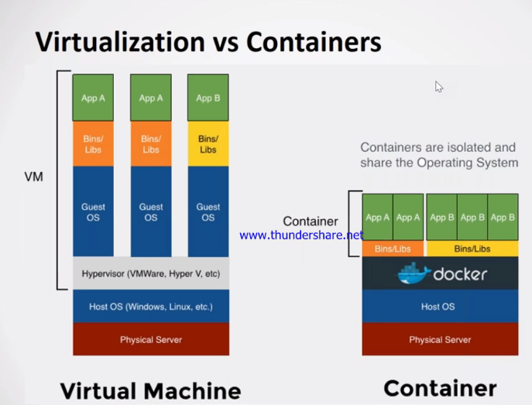

Docker has client server architecture.

* CLI (Command Line Interface) is a client
* Server Consists of Docker Daemon and Containers
* Docker server receives request from CLI in the form of commands or rest APIs.
* All the components of the architecture together forms DOCKER engine
* DOCKER client or Server can be present on same host or two different machines
* Container is a process
* Container does not have any KERNEL in it and thus uses very less RAM.
* Inside a container you have only one image.
* When you exit container, it will automatically stopped the container as nothing is running inside

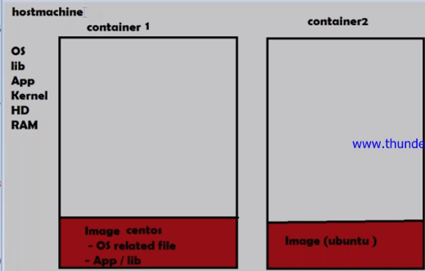

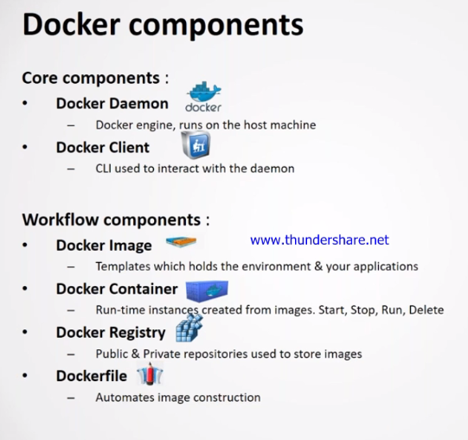

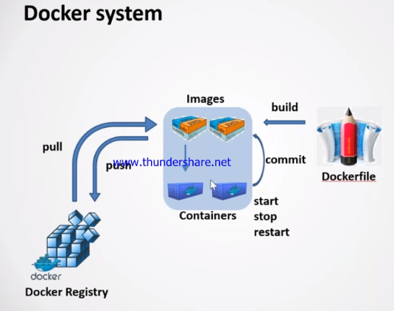

* **Creating Container**

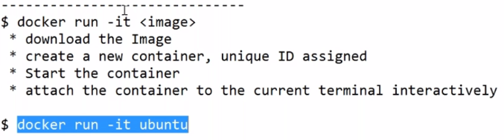

* If you want to re-login the container again the.
* Start the container first 🡪docker start container_id

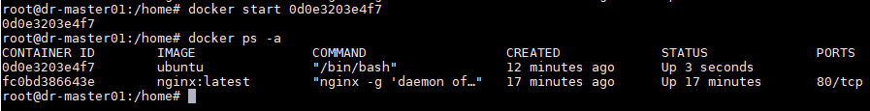

* If you already created the container in **interactive mode** then you just attach to it. Docker attach container id 🡪docker attach container_id



* This will take you inside the container you created previously.
* Tell container to run the first command or running your own command while creating container.
* docker run –it Ubuntu /bin/bash
* Providing name to the container
* docker run –it ---name <Container name> Ubuntu /bin/bash



* **DETACHED MODE**
* It always necessary to have some process running in detach mode.
* Whenever you detach the container, you cannot attach back to it.

Command to run in detach mode

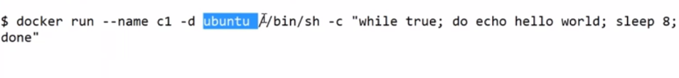

* docker logs –f c1 🡪will take you to container in detach mode to see what actually running inside.

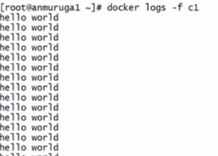

* When you want to run any other command inside a container which is created in detach mode the we use “**exec**”
* Docker exec <container_id> <cmd>

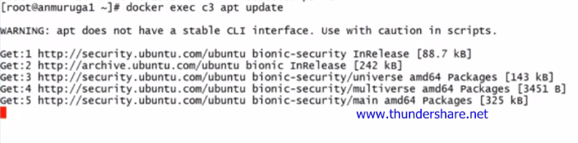

Now this “apt-update” is running inside container c3 as shown above.

**A HACK to Go inside the container running in detach mode is shown below:**

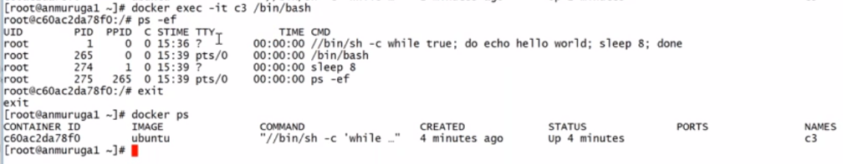

**When you exit the c3, it will only stop the process /bin/bash while the other process will continue running.**

* Delete a container is docker rm container_id

**PORT MAPPING**

* Port mapping is done while creating container and not after creating the container.
* 
* If the port is already in use then assign new port.

**VOLUME MAPPING**:

* In order to access some folder or files of container from host machine.
* Volume mapping is useful when you have many container and not possible to login to each container separately to access files or folders.
* Also, we can take back up of container’s content, in case if container deleted.

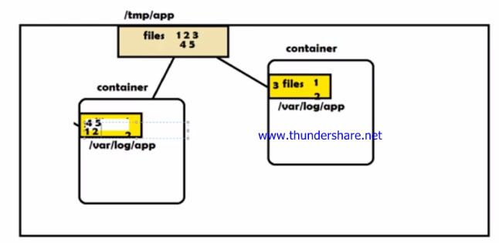

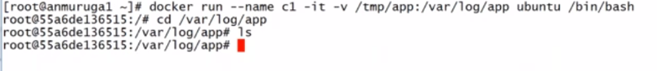

* If the folders are not available then it will created at the time of volume mapping.
* Whatever the changes we do in files or folders, it will reflect at both the sides.

Customizing or creating our own image:

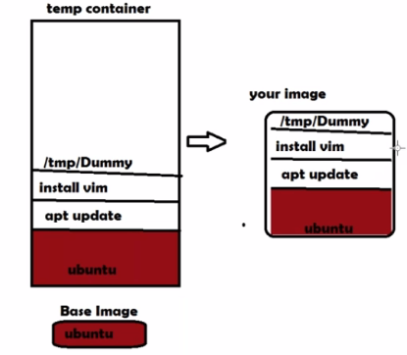

* Creating image manually from container is:

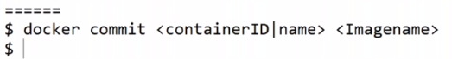

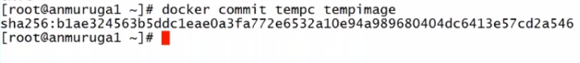

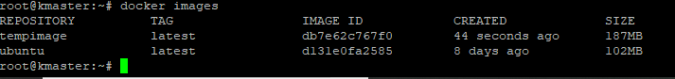

**Automated process of Building Images using Dockerfile**:

* Create a Docker file shown below:

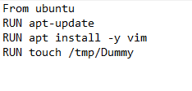

* Command to build image out of it.
* docker build –t <image_name> .

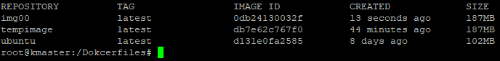

* Now, create a container out of img00.
* docker run –it --name=img00C img00 /bin/bash

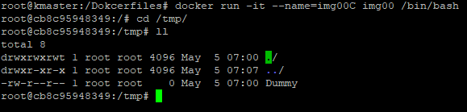

**DOCKERFILE SYNTAX:**

* **CMD**: When a user create a container out of the image and do not pass any command then commands specified with CMD in Dockerfile will be the first to execute inside the container.

If the user passes the command while creating container then this will take precedence over the commands specified in Dockerfile**.**

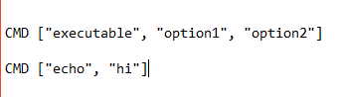

* It ran the echo hi and come out of container as process execution is finished and container is stopped.

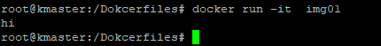

* When user pass commands while creating container then this command will take precedence.

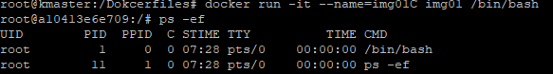

**ENTRYPOINT**

* 
* If user passes own command while creating container then Entrypoint will consider user commands as option and print both the options on the console.
* Example:

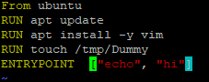

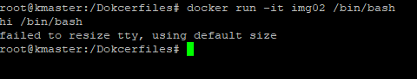

ENVIORMENT VARIBALES:

* 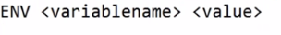
* 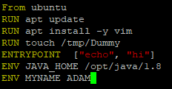

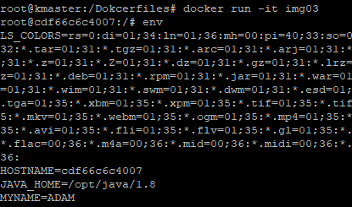

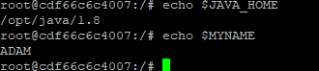

* USER
* Whatever you ran is based on user root, now suppose you what to change the user and execute some commands then



* Suppose, we created a file with user root, then created a user nobody and a file is created using this user. See below.

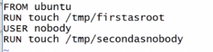

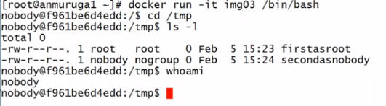

It came as the user nobody as last connected user in nobody.

* IF you want to connect as root user during runtime the use –u. See below



**WORKDIR**:

* When you mention this Dockerfile, then all the instructions will be executed from this working directory.
* 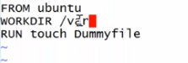
* Go to folder /var and create the file DummyFile.
* 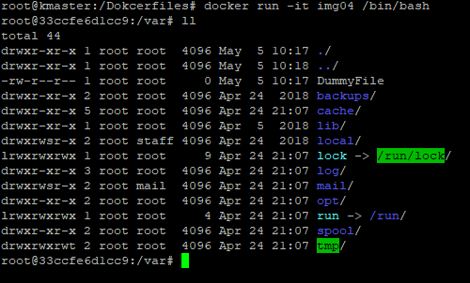
* As you see above, once the container is created, the working folder is var because at the var folder the image is created and whatever is the image state will have in container too and DummyFile is created inside it.
* You can also change the default folder during run time. See below

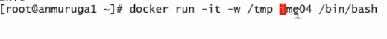

**COPY:**

* Copy a particular file from host file to container’s destination**.**

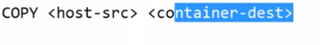

* 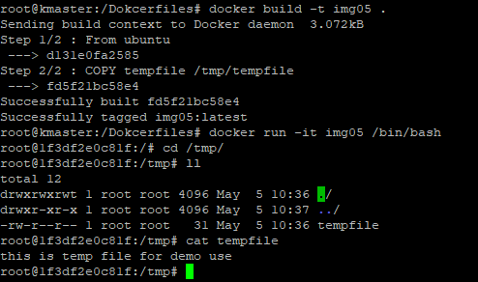
* To copy, make sure the content to be copied should be in the current directory where Dockerfile is present.

**ADD**

* Help to copy multiple files to destination when archived.
* Create .tar or zip file at host machine. Copy this tar file using Add.

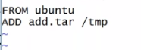

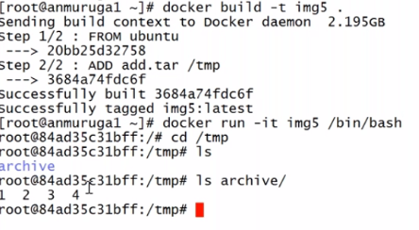

**EXPOSE:**

* 

IF there are many docker file then you can create other than Dockerfile name like Dockerfile.apahce.

While building an image out of it run below command

* Docker build –t -f ./Dockerfile.apahce **.**

**Docker file to create an apache image**.

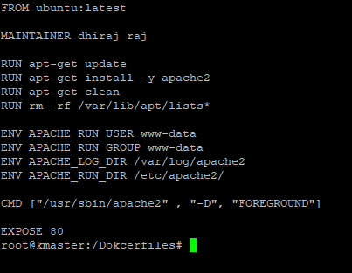

**Uploading images to Docker Registry**

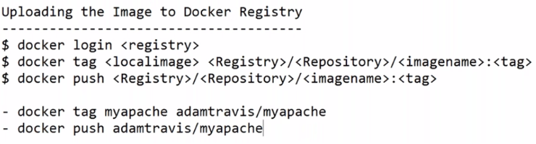

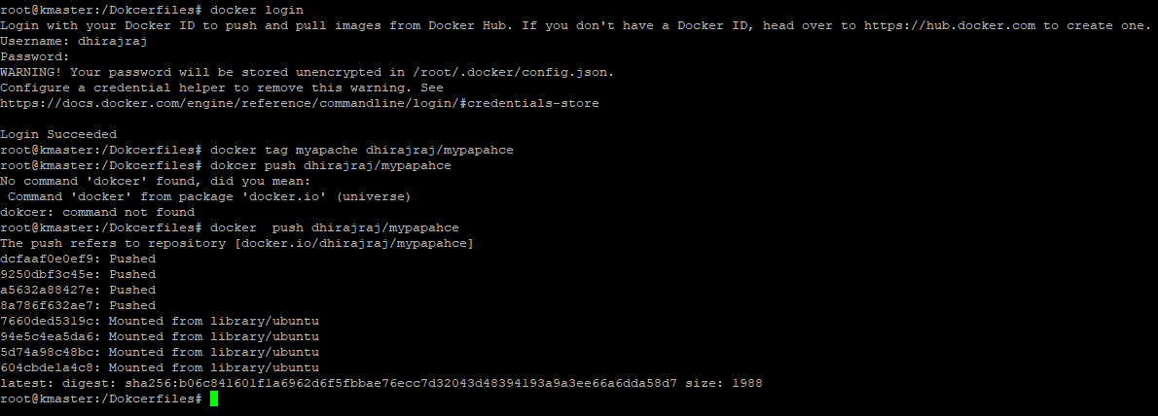

Creating Docker image from Jenkins using Docker file.

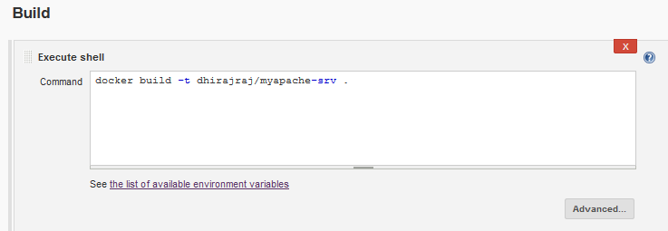

Now pushing it back to Docker Hub, use below methods

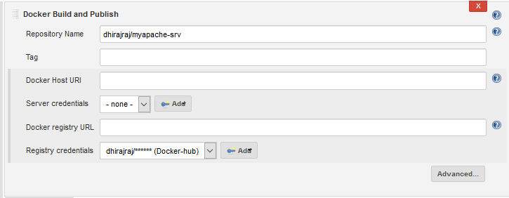

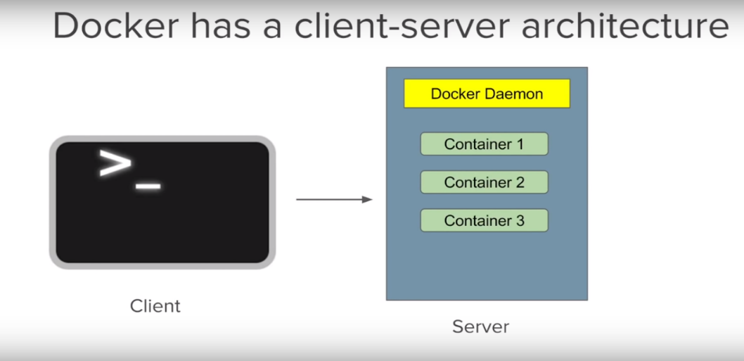

===============DOCKER ENGINE==================================

* Build once and run anywhere
* Like GIT, Docker has in built version controlling system, you can commit the changes to docker images

Docker Reference

<https://www.youtube.com/watch?v=YCrRy7pBzdc&list=PLhW3qG5bs-L99pQsZ74f-LC-tOEsBp2rK&index=3>

**docker registry hub**: dhirajraj/Mother123!

* docker run -it Ubuntu: latest 🡪 to create container from image
* docker start/stop container-id 🡪 Command to start/stop container
* docker attach container-id 🡪command to login to container
* docker stats🡪 give details about container utilization of machine
* docker system prune <option> 🡪 to delete unused container and images
* docker rmi image-id🡪 to remove images
* sudo service docker start🡪 start/stop docker daemon
* docker rm container_id 🡪 to delete stopped container

**MADHU SUDHAN REDYY Y.B**

**This playlist for all Devops Topics (MUST READ)**

<https://www.youtube.com/channel/UCxGMOu0QDJYYc2pXndonKpQ/videos>

**Use case**

Using Jenkins, Create a Dokcerimage using docker file and push the image to Docker Hub

From Docker hub, deploy the docker image to production environment,

**DOCKERFIILE CONCEPTS**;

<https://www.youtube.com/watch?v=2lU9zdrs9bM> 🡪edureka

<https://docs.docker.com/engine/reference/builder/>

<https://www.youtube.com/watch?v=LQjaJINkQXY> 🡪raghav pal

**Docker FILE basic Commands**

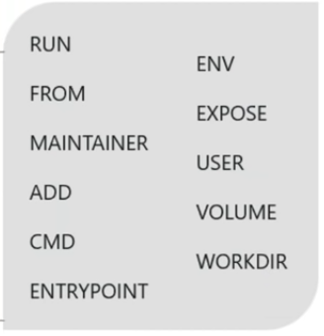

**Writing docker file**

* pull base image from docker hub (like Ubuntu or cent-os or any other OS)
* open a text file and name as DocerFile without extension
* FROM 🡪to specify Base image (like Ubuntu or centos)
* RUN🡪 to install application like java or any other app, it accepts arguments

Run argument1, argument2 etc.

* CMD🡪 it does not build docker image, CMD commands executed first
* ENTRYPOINT🡪 Once the docker image is built then Command define in entrypoint will be executed first
* ENTRYPONIT over-rides CMD command

Example

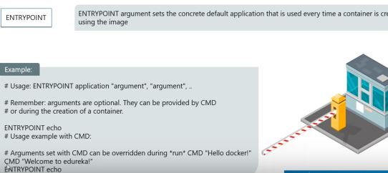

In above diagram, ENTRYPONIT echo overrides CMD “Welcome to edureka”

* ADD or COPY🡪 to copy file from one location to other
* ENV🡪 use to set environment variable
* WORKDIR🡪 use to customize the path inside container from where the CMD command is to be executed
* EXPOSE🡪 use to specify to enable n/w port inside container.
* MAINTAINER🡪non-executing command use to specify author name, it comes after FROM command.
* USER🡪 use to set userID or username which is to run container.
* VOLUME🡪a path use to store file, use for mounting.

Command to run dockerfile

Docker build –t <name of image> <dockerfile path>

**PORT MAPPING**

Container port mapped to host mage

Docker run –p 80 (of host):80(of container) <image_name>

**Cloudbees docker build and publish plugin** 🡪 need to install this plugin in case you want to build image from docker file and publish to docker hub

Docker image Deployment using Dockerfile and Jenkins **and push to Docker HUB**

* Create a dockerfile
* Commit to git hub repo
* In Build Section , select Docker Build and publish as shown

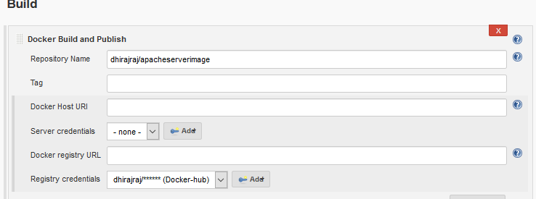

* Build Now
* Verify the image at docker host and GIT hub
* Create container out of this image

**Packaging your .jar or .war files into a Docker container | Docker & Java**

<https://www.youtube.com/watch?v=6rGMvws--kk>

# Docker - Demo CMD vs ENTRYPOINT

<https://www.youtube.com/watch?v=6lcYyo9e7-0>

# Git Revert, Reset (Hard, Soft, Mixed) - Checkout

<https://www.youtube.com/watch?v=VUuGa1QFmcA>

**Container Management**

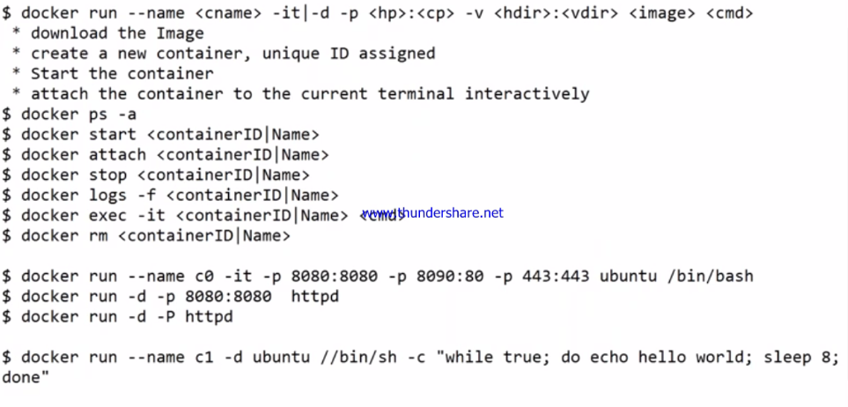

We cannot create empty container that’s the reason we need base image.

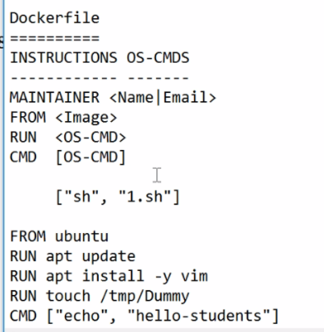

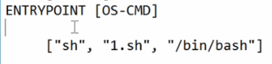

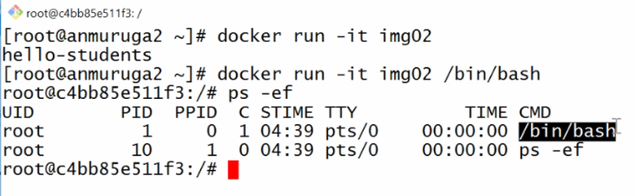

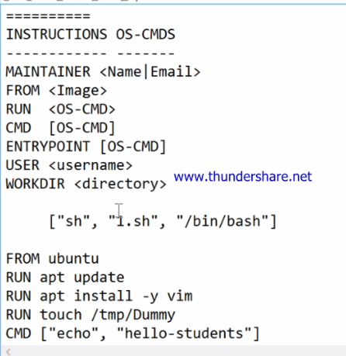

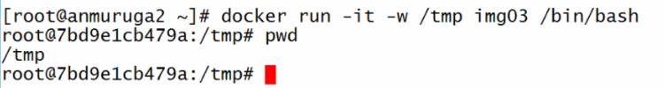

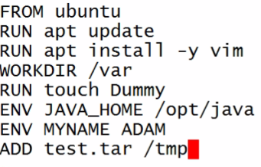

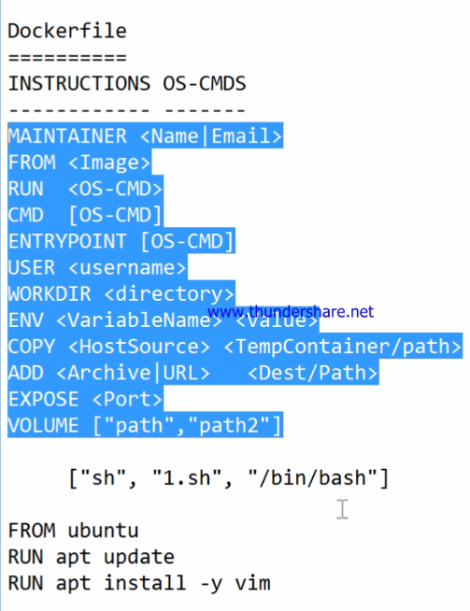

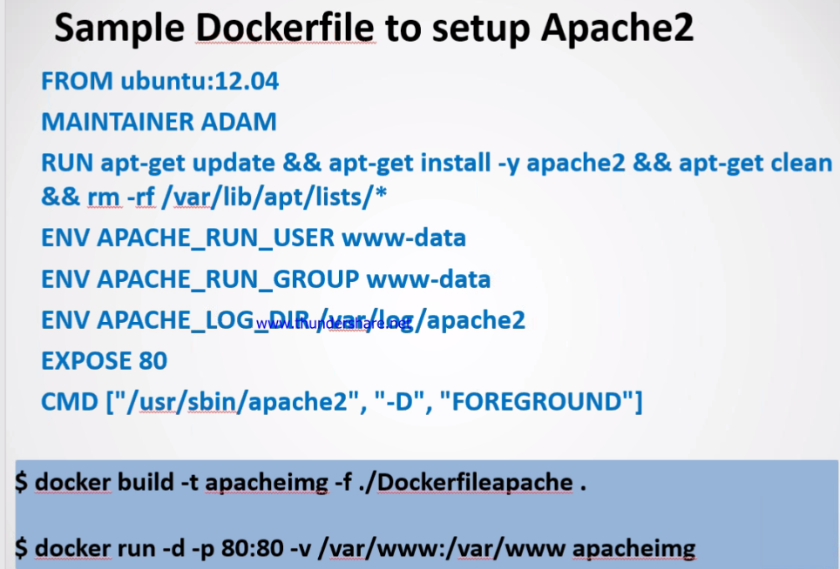

**DOCKER COMPOSE**

**Compose is a tool for defining and running multi-container Docker applications**

* Create Docker compose file

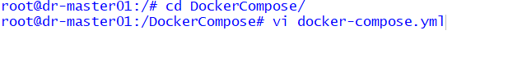

* Define docker-compose.yml file for multi-container app (Suppose in one image u have our DB and one image u have your webserver, think this as one application all together) .Below is the simple docker-compose file to run web and Db as services

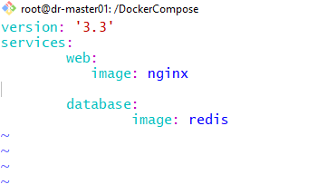

* To check the validity of command use :

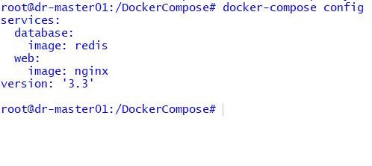

* Start docker-compose using command in detach mode

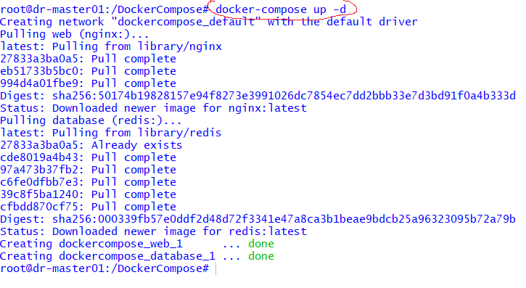

* Check the status of container created from the images



* To stop container

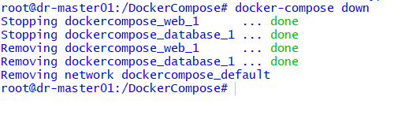

**SCALE SERVICES**

**Docker-compose up –scale <service_name> =<no. of container>**

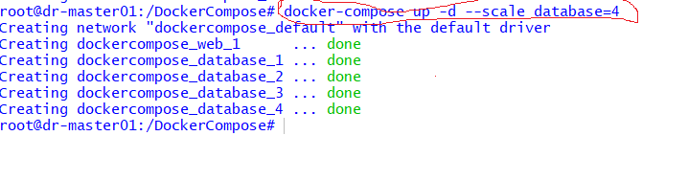

**After scaling the service database**

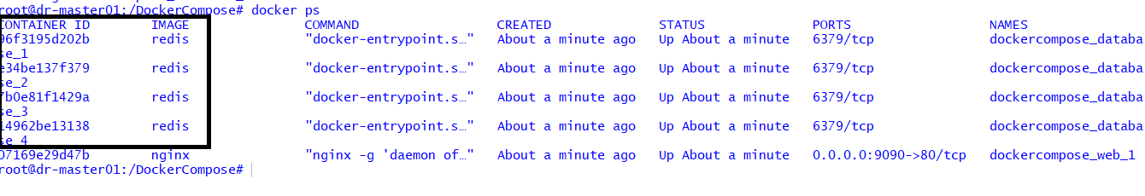

**DOCKER-COMPOSE VIDEO BASIC**

[**https://www.youtube.com/watch?v=HUpIoF_conA**](https://www.youtube.com/watch?v=HUpIoF_conA)

**DOCKER SWARM**

Docker swarm is group of machines which have docker running and joined into a cluster. It is a tool for container orchestration

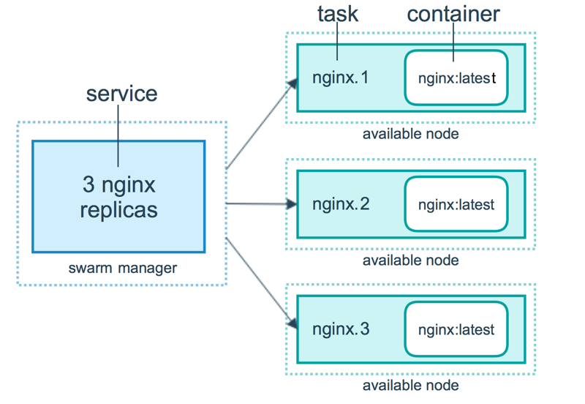

* Initialize docker swarm

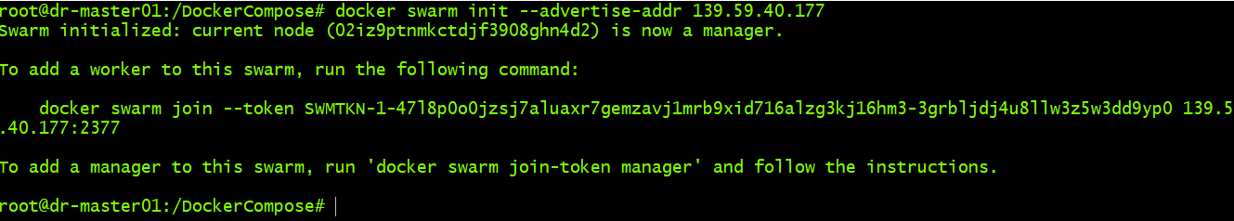

* Default port is 2377
* An overlay network is created

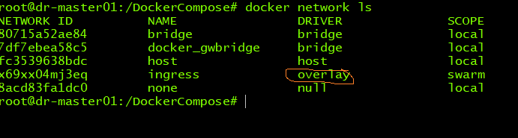

* Check the number of nodes running



* Now go to your docker node machine and run below command to joint to master.



* Now go back to your master nde and run the below command again

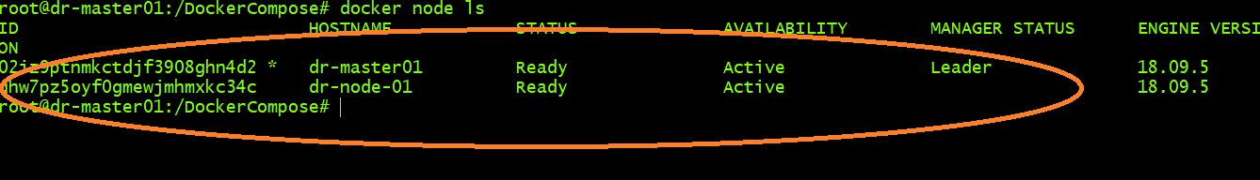

* As you see both the master and worker in now joined
* You can also create multi-manager

Just run this command docker swarm join-token manager

* Run the below command , in case you want details about node/manager

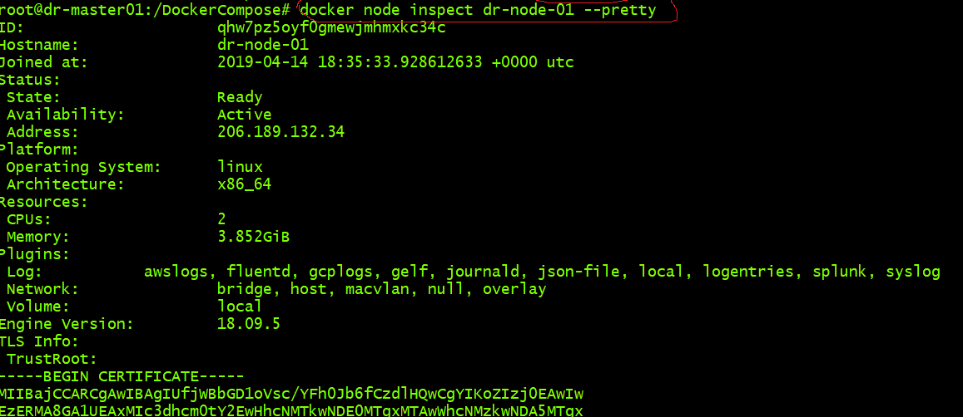

DOCKER SWARM IMPORTANT COMMANDS

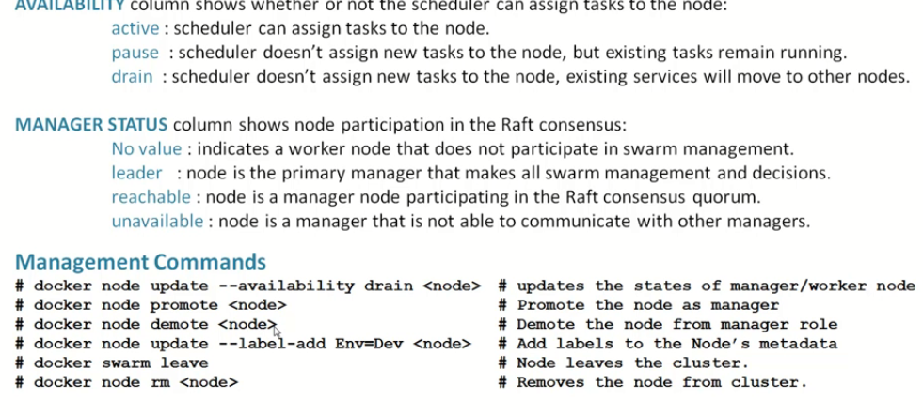

* Command to change the availability of node

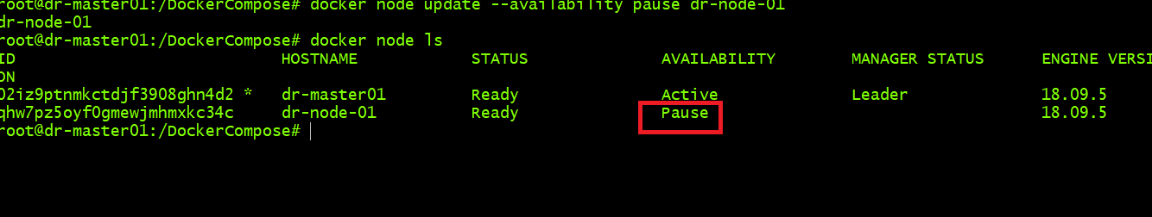

* Command to promote node as leader

*docker node promote <node_name>*

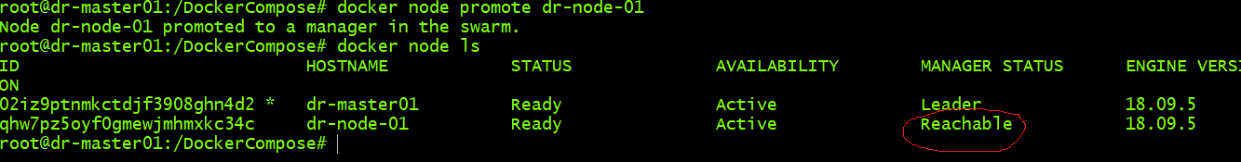

* Command to demote node from leader

*docker node demote <node_name>*

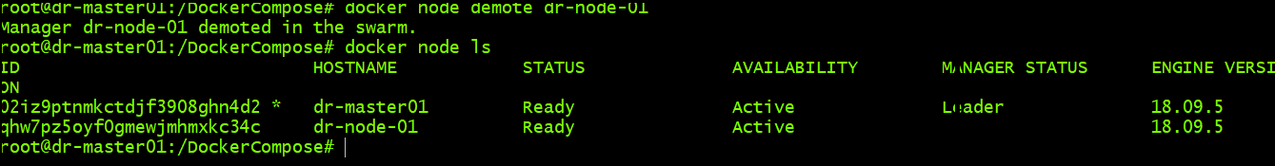

* Node leaves the cluster

*docker swarm leave* (run this command from node machine, then go back to manager node and run *docker rm <node_name>)*

* In Docker swarm , we work with services and not containers

**HOW TO CREATE SERVICES IN DOCKER SWARM**

docker service create --replicas 2 –p 80:80 --name myweb nginx

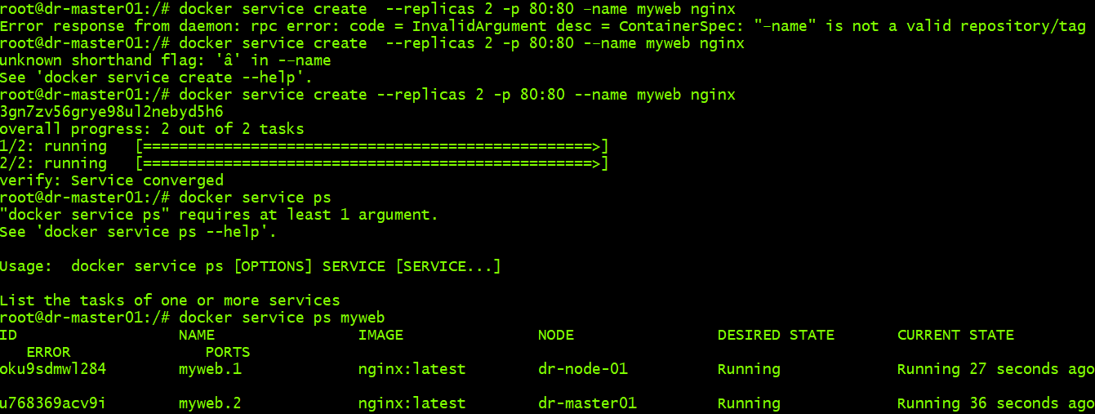

**See above, services are running in both master and worker**

**DOCKER SWARM TO SCALE/DESCALE SERVICES**

*docker service scale <service_name>=replicas*

This command will create number of replicas on master/worker node

Suppose replica=4 then scale the service by 2 on manager and 2 on worker node.

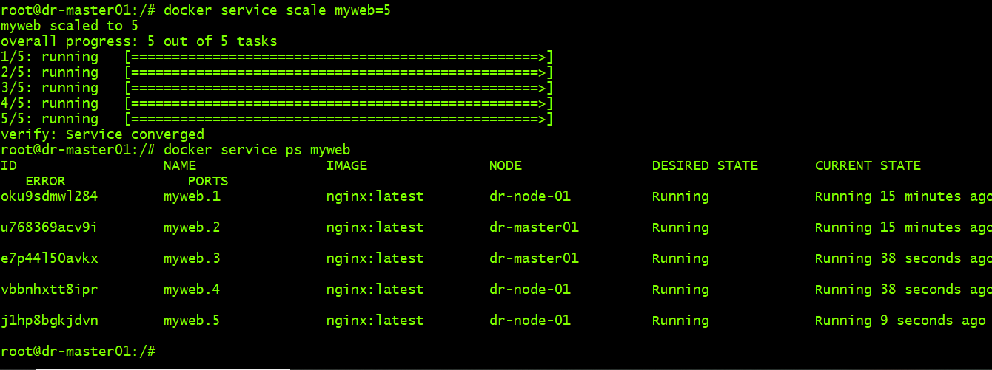

**DESCALE**

Just lower the replica number

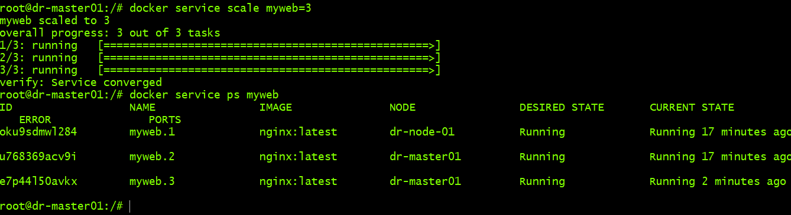

Replica means, docker swarm will tell that at any single point the replica=3, 4 etc. will maintain the same even if it get deleted by mistake, automatically the replica number will be restored . We don’t have to do anything.

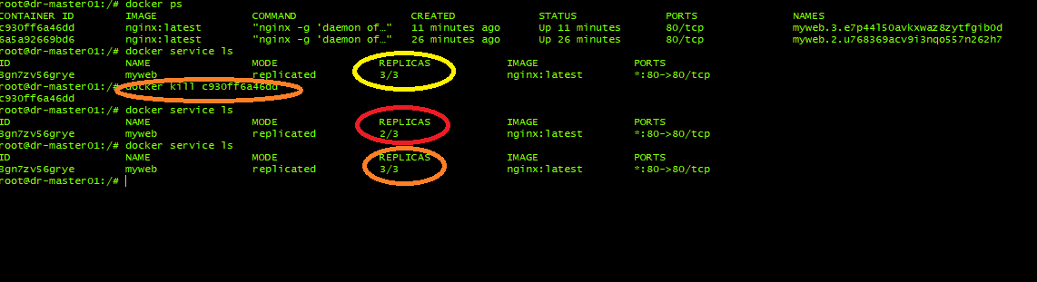

In the above screenshot.

* Replica was 3
* Then one container deleted
* The replica=2
* After few seconds replica automatically 3

**Docker Questions**

* Can we write compose file in json file instead of yaml?
* What are the main features of Docker-compose?
* Can we run more than one process in a Docker container
* What are the objects created by Docker Cloud in Amazon Web Services (AWS) EC2?
* What is ONBUILD command in Docker?
* How will you monitor Docker in production?
* How to run multiple containers using a single service

**PUPPET**

* Agent based cm tool
* Pull based
* Puppet 6 is current version
* Works in master-slave architecture
* The nodes sends there current state in normalized form to master server
* Based on the facts received from nodes, master server compiles a catalogue for desired states of nodes
* The nodes report back to server that al configuration is applied

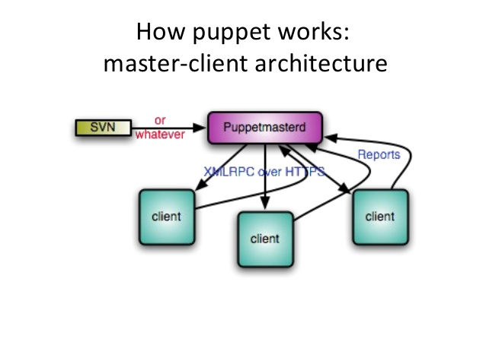

**ANSIBLE-CONCEPTS**

* apt install –y ansible
* Ansible uses Push approach

Configuration folder in Ubuntu

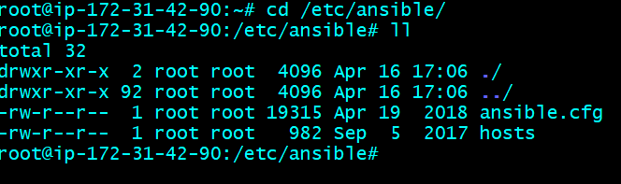

**How Ansible Works**:

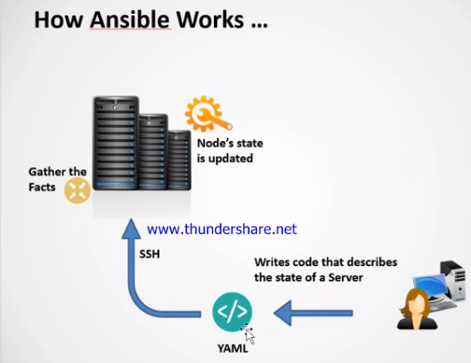

Ansible executable

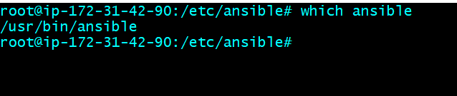

**Hosts file**

* Add group name in hosts file and under group name declare machine IP or FQDN

[groupname]

IP | username | password

Adding group and machines



Ansible Adhoc commands

* ansible [group or hosts] –m <module> -a <cmd>

Copy file from master to different nodes

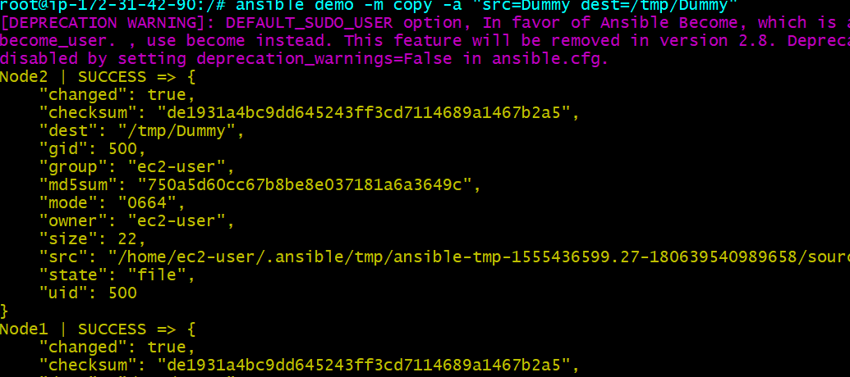

Changed= true means it has successfully completed the copy operation

Install apache on different nodes (Before installing make sure you are a root user)

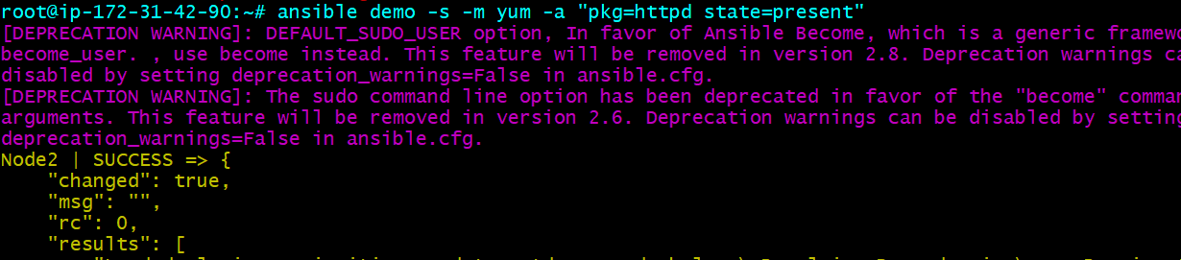

-s =sudo

Uninstall Apache🡪 state=absent

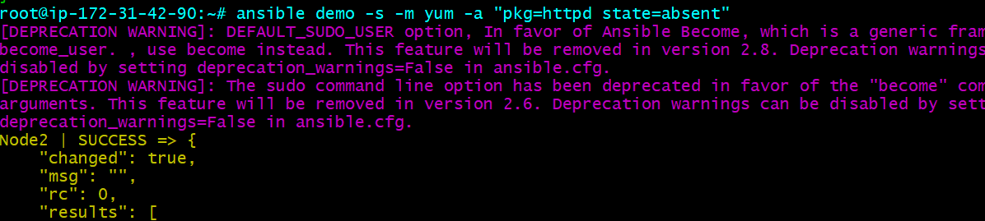

Start Apache Service 🡪 name=httpd, state=started/Stopped/restarted

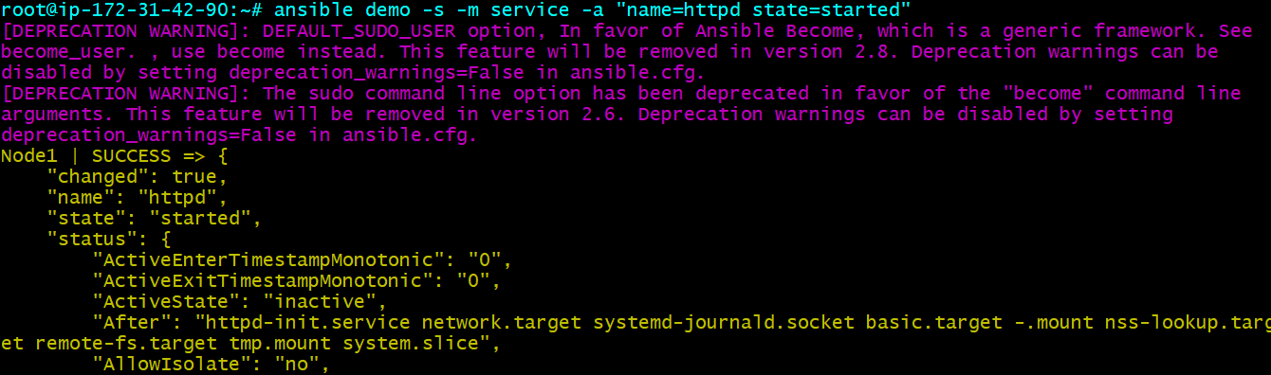

Adding a user to nodes

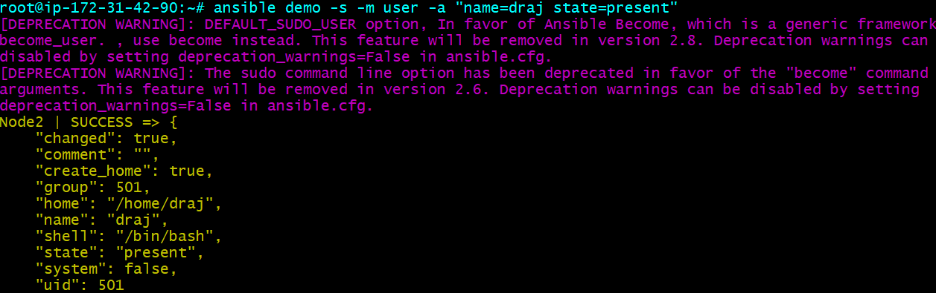

**PLAYBOOKS**

Executable

/usr/bin/ansible-playbook

ansible-playbook <playbook.yml>

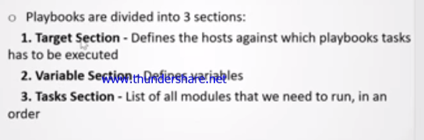

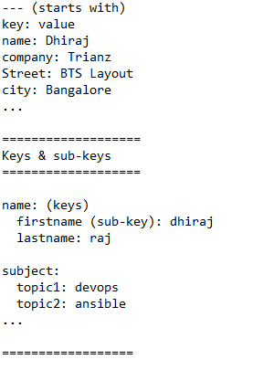

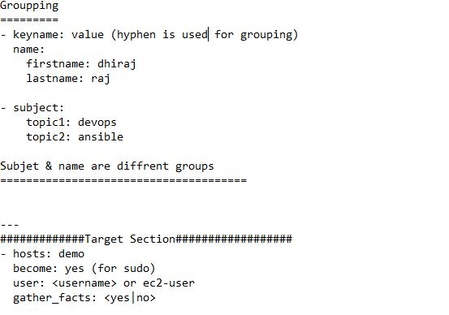

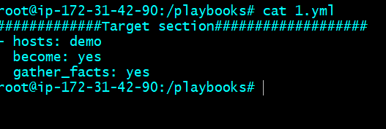

Tasks –section

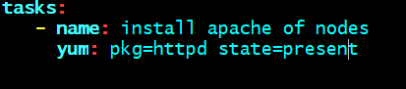

Yum is **module** name and pkg=httpd state=present is **arbitrary**

**Complete .yml file to install apache**

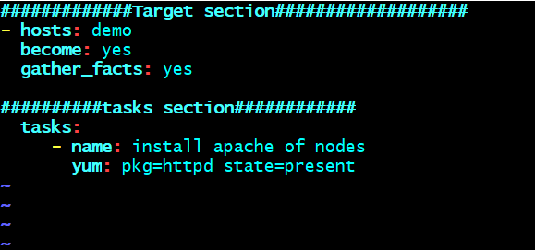

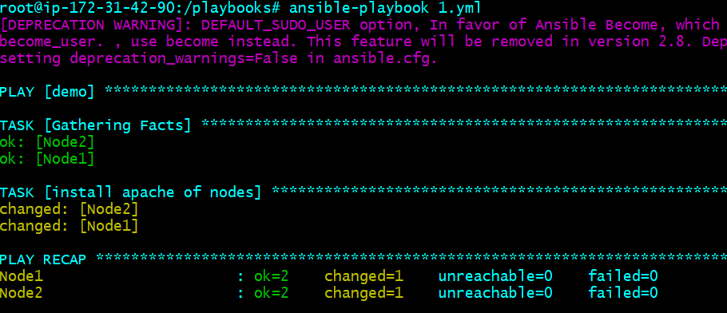

# Create docker containers using Ansible playbook

<https://www.youtube.com/watch?v=lqEnooL0BkI> (an awesome use case)

**Variable Section**: variable defined in target section and used in tasks section:

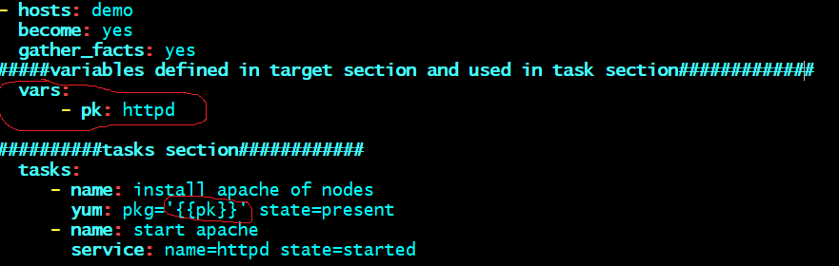

Module to capture output while running ansible playbook

* register module capture o/p inside a variable register: <variable_name>
* Define register inside tasks section
* display the captured output using DEBUG : var : variable_name

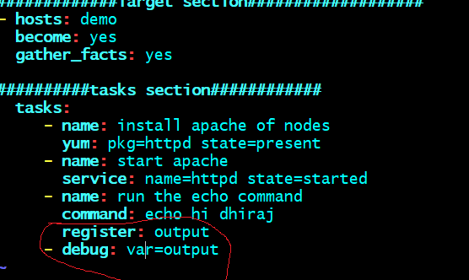

* For every tasks, you can define register and Debug. See below:

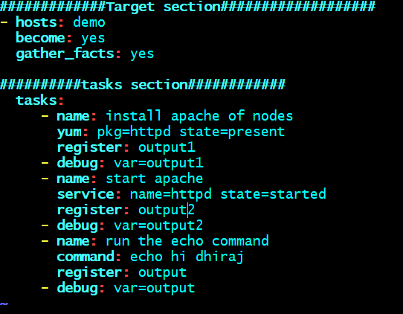

Handler Sections:

* Used when there is dependency b/w two tasks.
* Execute the second tasks when the first tasks status is changed=1
* Notify=<task name> , if the state of the task1 changed then keyword “notify” will notify task2 to execute

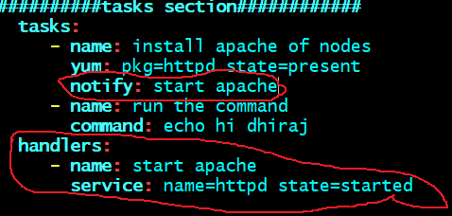

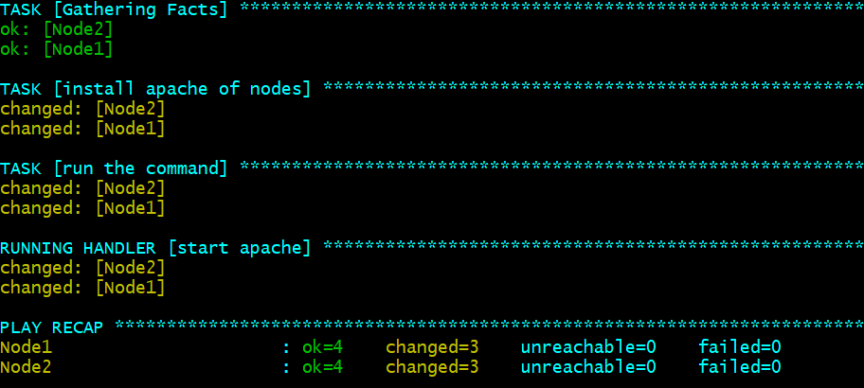

Executing each tasks parallel on different Nodes

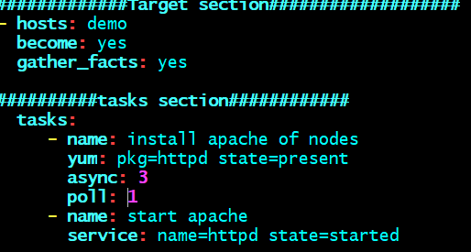

RUN ONCE🡪 Running a tasks only once in a node

Run_once: true

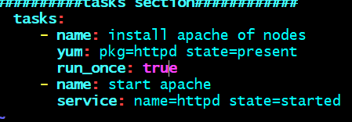

It has run the task “install apache” only once

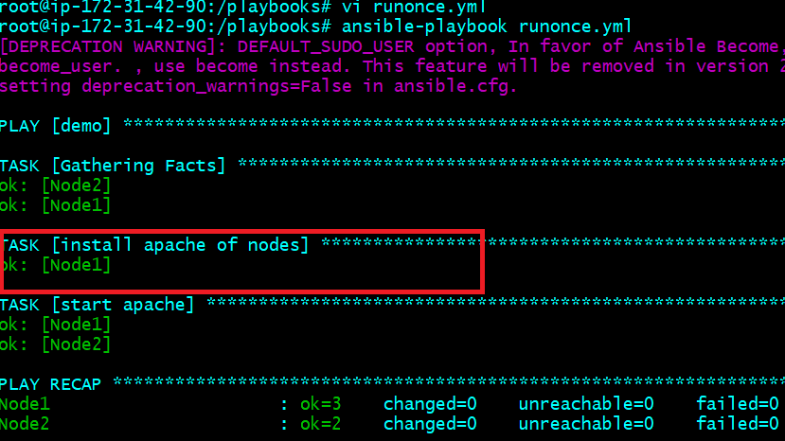

You can also select which node to run once

Delegate_to: <node_name>

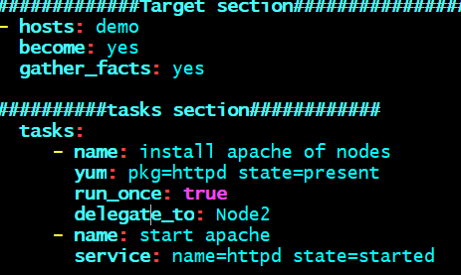

See the output: IP is of Node 2

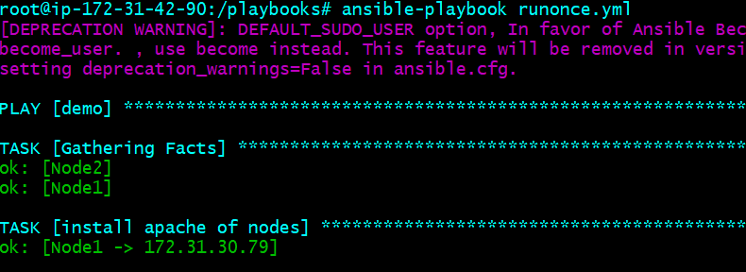

LOOPS

* Looping is used when you have to perform same tasks with different values.
* Suppose you have to install java, git on a node machine, the command will be same, but pkg name will be different and this is looping in ansible.

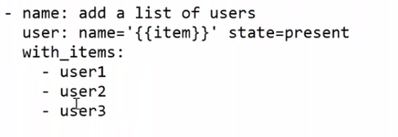

* **with_items** is keyword used for looping
* The **Item** is default variable used here.
* In first iteration it will take value as “user1, then user2 etc.
* This will create 3 users in different nodes

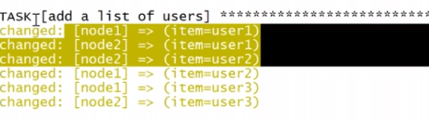

These many users added in different nodes

**CONDITIONAL in Ansible**

* When is the keyword used for conditional statement
* When the condition match then it will execute the tasks, else it will skip

ansible all –m setup | grep –i family

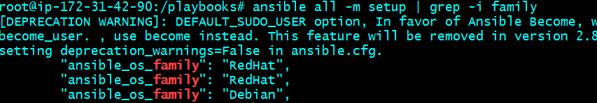

If the value of **ansible_os_family: Redhat**, then it will execute that task on the machines else it will skip the tasks on that node.

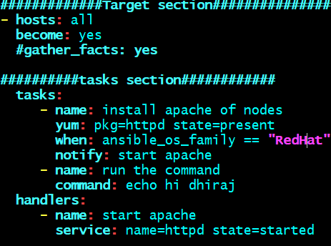

If you see below, master node is skipped as its Ubuntu machine and Red Hat is used for CentOS

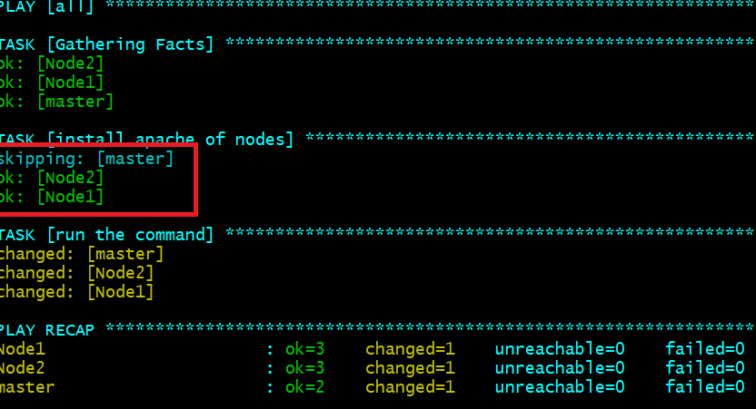

A playbook to print numbers greater than 3

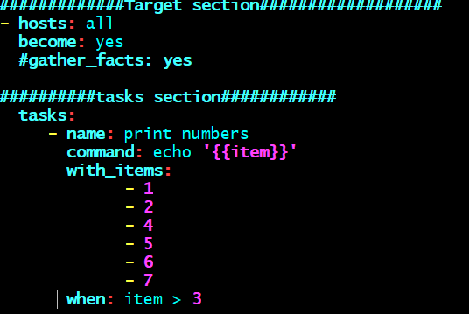

Stat module: (to check presence of certain files in different nodes)

**stat: path=/tmp/theFile**

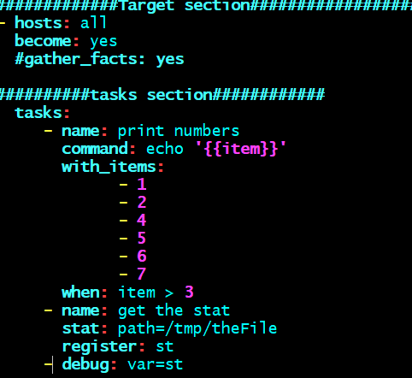

Command to create a file of nodes

Shell: touch /tmp/theFile

When: not stat.st.exists

**Error handling:**

If an error encountered ansible will stop the execution there itself, if you want to continue the execution even though the error is encountered then there is a keyword called

*Ignore_errors: yes*

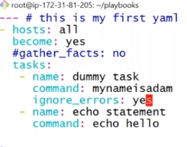

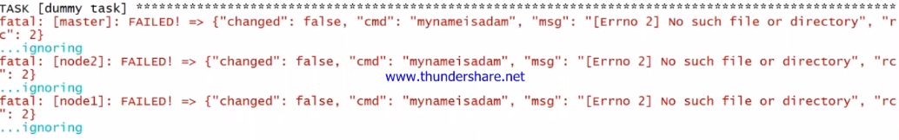

Error is ignored and moved to other tasks.

**WAIT**:

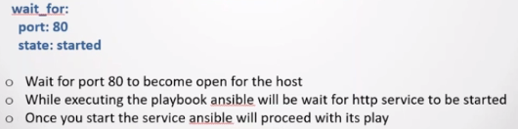

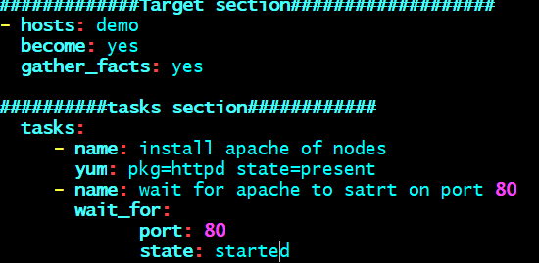

TAGS:



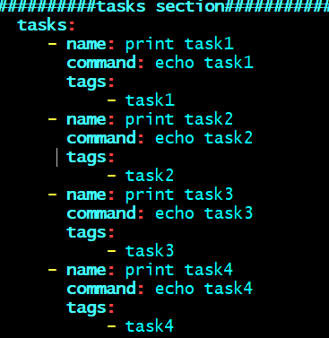

Now we can execute particular task from this playbook by using respective tags:

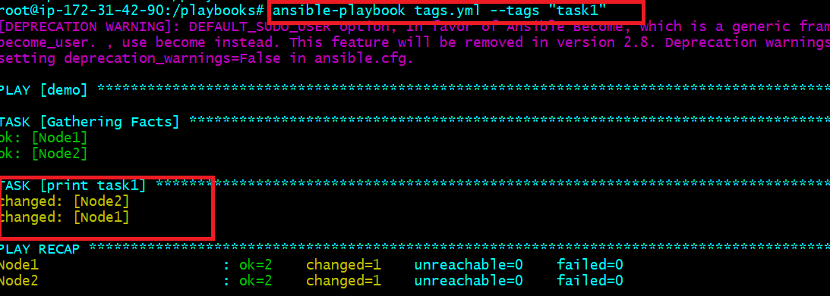

We can also mention multiple tags one or more tasks so that it will invoke those tasks. See below

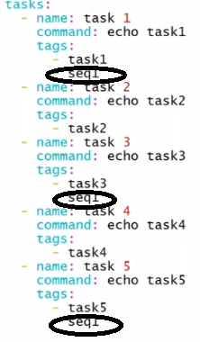

You can also skip particular tasks by using tags:



Vault:



Encrypt:

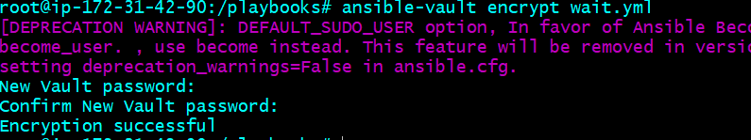

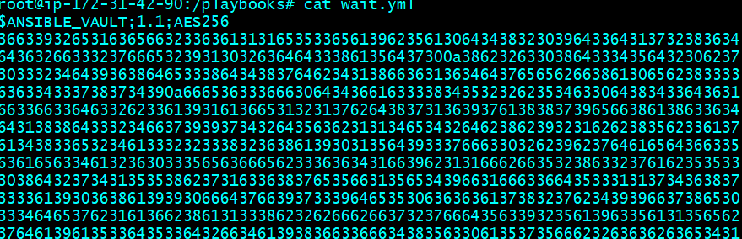

Edit: to edit file content

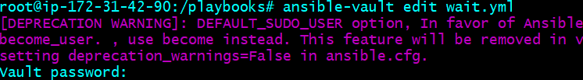

Decrypt: to decrypt the file

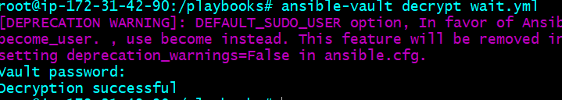

While running playbook, you can enter –ask-vault-pass for password

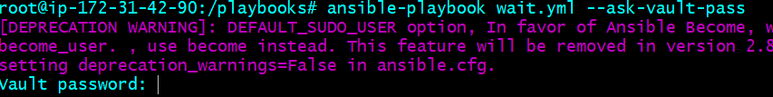

ROLES

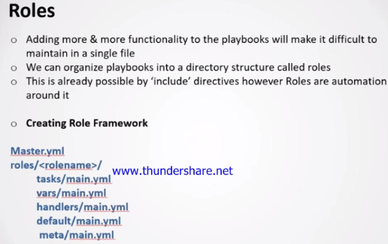

Refer video 7 for more details

**KUBERNETES by JankiRam**  
<https://www.youtube.com/watch?v=_vHTaIJm9uY&list=PLF3s2WICJlqOiymMaTLjwwHz-MSVbtJPQ>

3 <https://www.youtube.com/watch?v=o0SXHuv2CVw>  
4 <https://www.youtube.com/watch?v=YI0yX1Bz6tk>  
5 <https://www.youtube.com/watch?v=LS57ul_cTsA...revise> the microservices concepts

There are two more videos by JankiRam MSV,,,please search there associated with the above links only....

**KUBERNETS INTRO BY EDUREKA**

<https://www.youtube.com/watch?v=F-p_7XaEC84> (MSUT WATCH)

**Ansible: Password less authentication**

[**https://www.tecmint.com/ssh-passwordless-login-using-ssh-keygen-in-5-easy-steps/**](https://www.tecmint.com/ssh-passwordless-login-using-ssh-keygen-in-5-easy-steps/)

**Deployment using Ansible**

[**https://www.youtube.com/watch?v=nE4b9mW2ym0&t=224s**](https://www.youtube.com/watch?v=nE4b9mW2ym0&t=224s)

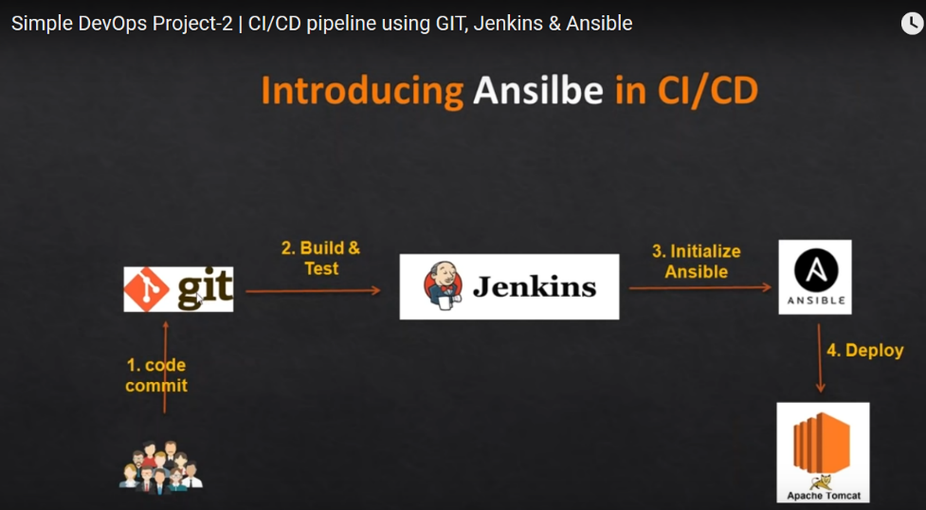

**To copy a file from a local to a remote system run the following command:**

*scp file.txt* [*remote_username@10.10.0.2:/remote/directory*](mailto:remote_username@10.10.0.2:/remote/directory)

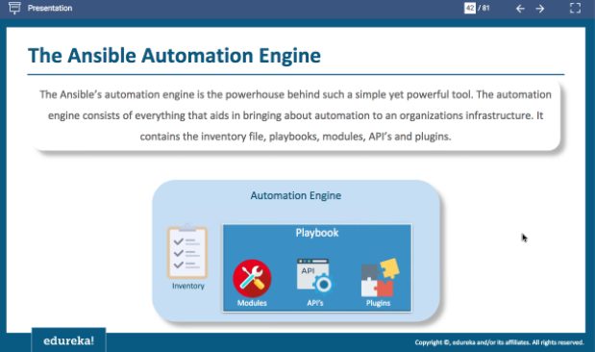

**For Ansible password less authentication set up:**

* 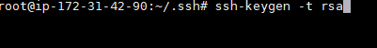
* Got to directory /root/.ssh and run below

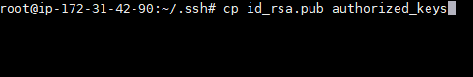

* Change the permission of the public key

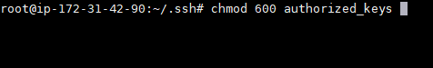

* Copy the public key on target node



* Then login without password.



* Vi /etc/ansible/hosts and add ip address or hostname in the file

**GIT**

* No concepts of server and client
* Works on Distributed Model

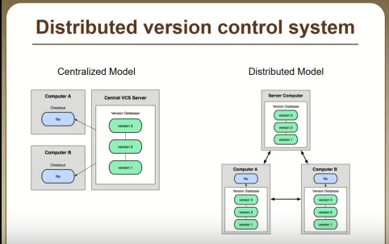

* In GIT, everything is workspace
* In Every workspace, there is copy of repository.
* GIT creates 40 char commit ID.
* In Git, there is workdir where we modify files
* In working DIR, we modify untracked files.
* Put the file to staging area for tracking.
* From staging, we do commit to put the changes of file to local git repo as shown below. It creates 40 char commit ids.
* Last, we pushes the changes to distributed Repo.

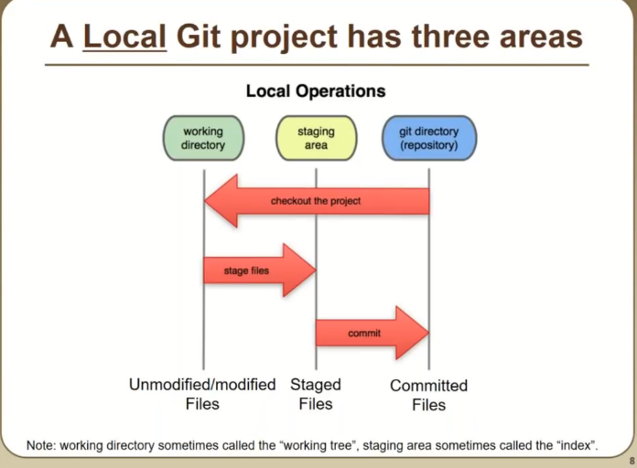

GIT WORKSPACE

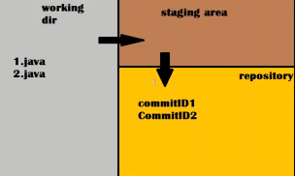

A file is tracked based on its commit id present in GIT REPO.

**GIT FILE LIFECYCLE**

* Any new file created in working dir is called as untracked files and unmodified
* When we move the file to staging area, it is called as staged file.
* From Staging area, we do commit, It will have commit id in local GIT REPO.
* Now, the file is tracked using the commit ID, but the file is Unmodified, because

the content of the file in repo is exactly the same as Working DIR.

* Again, in workigDIR, when you do any modification, GIT repo will track this based on commit id and stage is modified.
* From modified, it will move to staging area.
* From staging, will commit to GIT repo, file is tracked and stage in unmodified because the content is same as workingdir.

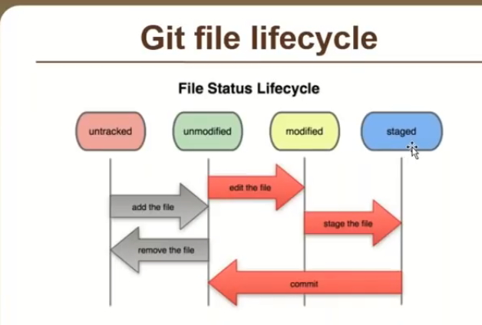

Git log (list out commit id history)

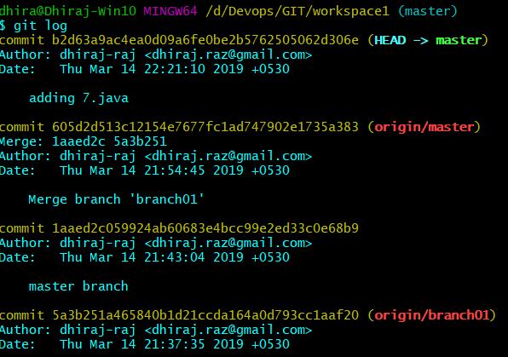

**All the references which are available in local workspace will be available in central repo after git push.**

**WORKFLOW**

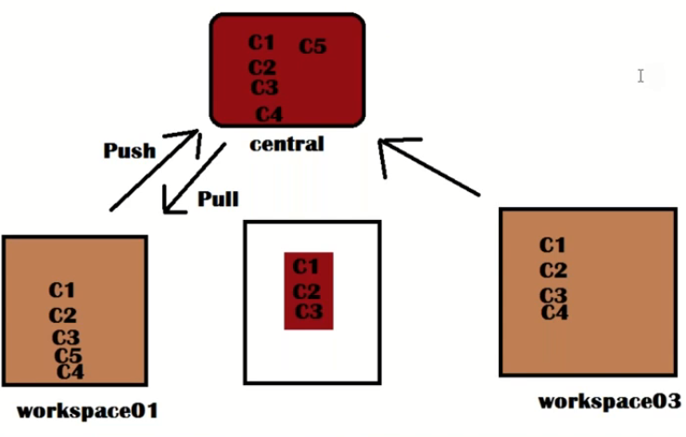

Git log filter option:

Git log –oneline –grep “file”🡪 this will grep the word file from all commit ids and display

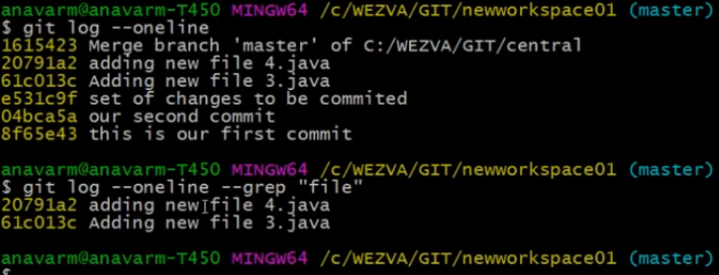

**GIT IGNORE**

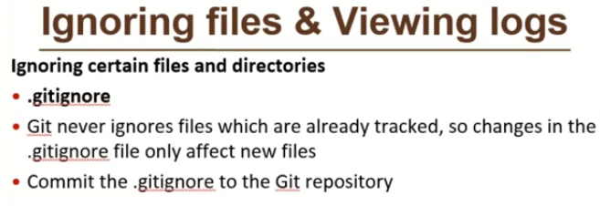

* touch .gitignore🡪 it will create a hidden file
* put the file you want to ignore in .gitignore file

echo “1.class” > .gitignore

* git status will ignore 1.class file
* .gitignore file need to add to repository, but files added to .gitignore will not be tracked by repo.
* You can also define certain pattern inside the .gitignore.

Ex: *.class

*.log

These extension will be ignored.

**BRANCHING**

* it is used for parallel releases scenarios
* All the commit id resides in default branch “master”
* Git branch 🡪 list out all the branches
* Git branch <branch_name> 🡪 create new branch (it will have copy of previous branch)
* Git checkout <branch_nme> 🡪 switch to any branch
* When you switch from branch, then new branch will get the copy of all commit id of previous branch. See below:

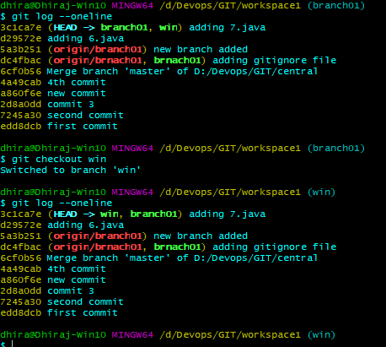

* Anything you do is known to that workspace only

**MERGE:**

* git merge <source> <destination>

**Scenario 1:** When you created a branch and only you are working on it, nobody else want that branch on central repo. So in this case we merge the changes to master first and from master branch we push to central repo.

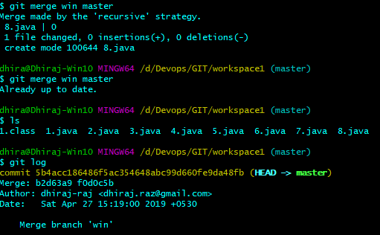

**SCENARIO 2:** Suppose a team of developers is working on the branch you created (other than master). Then in this case will push this branch to the central repo first. All the braches and its content is now available to central repo .See below

git push –u –all

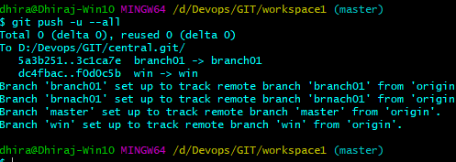

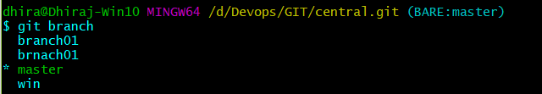

**Cheryy-pick**

* when you want to merge a particular commit id

git cherry-pick <commit_id>

**STASH**:

* Situation where, you are working on a fix and you have certain ideas of the fix.
* Or you want to apply new idea as a fix , so whatever changes you have written should not be over written
* So you have to take the backup.
* Git stash will take backup of the file and undo the changes in workingdir.
* See below, there are some changes applied to 5.java and 6.java, but I don’t want to commit it right now. I want to create backup of the changes for later use.

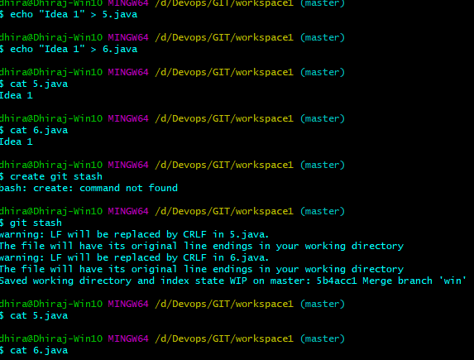

* After git stash, it will undo the changes to workingdir.
* If you want to see stash list run *git stash list*

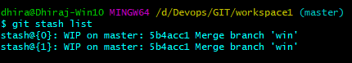

* Stashing list stores in array format, means every time the last change will have the first index in array. See below

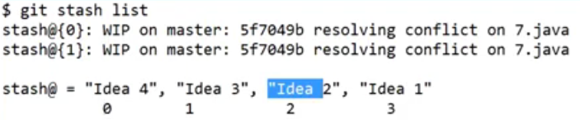

* Now, if you apply the idea 1 as the changes then, simply do.

*Git stash apply stash@{i}* 🡪 where i is the index

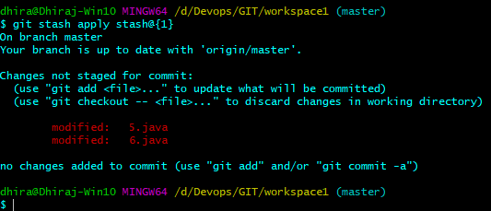

* Now idea 1 is added to the working-dir , we have to do git add. And git commit.

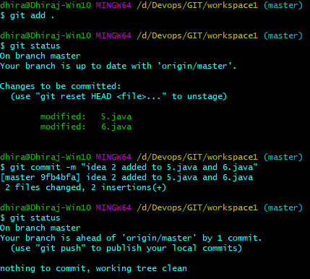

* But git stash still have the backup, so go and clear the back up using *git stash clear*

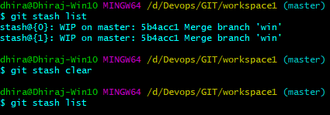

* Backup is cleared now.

**Reset CHANGES (undoing the changes before committing)**

* git reset <modes> has three modes : soft , mixed & hard

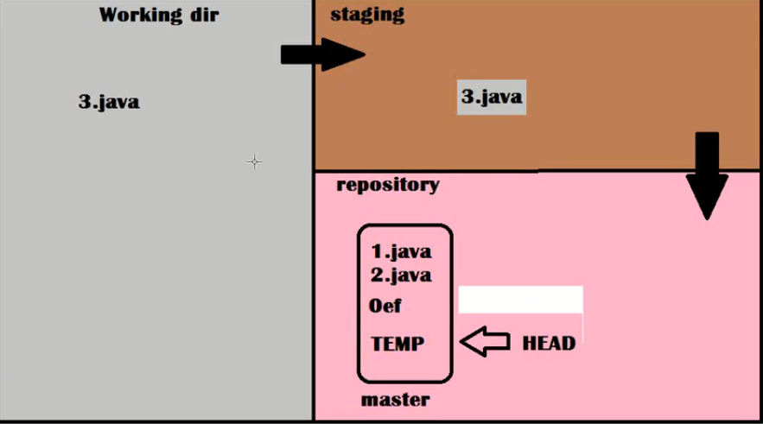

Soft 🡪 *git reset soft* will move the HEAD to original commit from the TEMP commit id, but changes will be remain in staging and working dir . See below

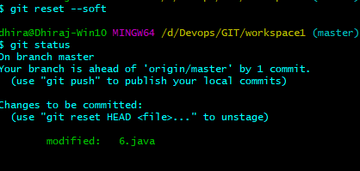

Mixed: git reset mixed 🡪 will reset the changes from staging area and move the HEAD to original commit id in the repository. But, the changes will remain in working dir.

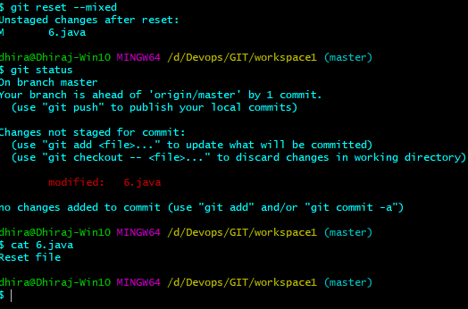

Hard mode 🡪 will reset the changes from staging area and move the HEAD to original commit id in the repository as well as undo the changes from working dir.

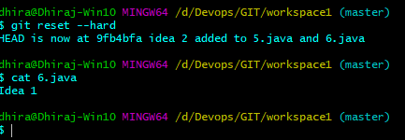

Changes has been deleted from 6.java

**REVERT** **(undoing the changes after committing)**

Reverting uncommitted changes:

*git revert commit id*

When you do revert, git will not delete the faulty commit id , rather it will create a new commit id on previous content.

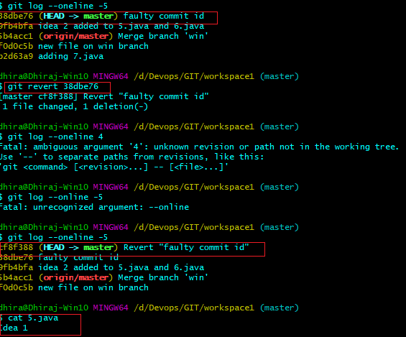

How to traverse from one commit ID to other commit ID:

Suppose in working dir , the file have many commit id and the head is pointing to the latest commit id. If you want to traverse from latest to oldest then we use “git checkout <commit id>”

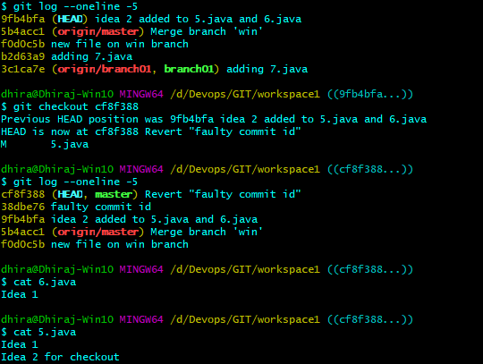

git checkout currentbranch@@commitid 🡪if you don’t specify branch, it will take current branch

git checkout branch@@commitid 🡪 if you don’t specify commit, it will take to latest commit id.

Delete a file and creating a reference to it.

*git rm <filename>*

**Cloning REMOTE REPO GIT HUB**

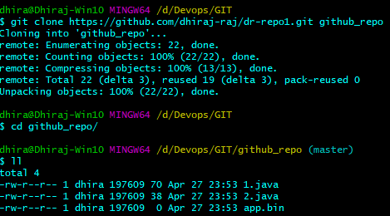

**JENKIS CONCEPTS**

Continuous Integration Concepts 🡪 <https://www.youtube.com/watch?v=p7-U1_E_j3w>

Video 2 🡪

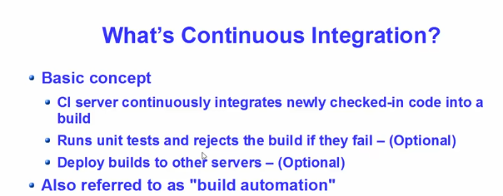

Continuous Integration Concepts:

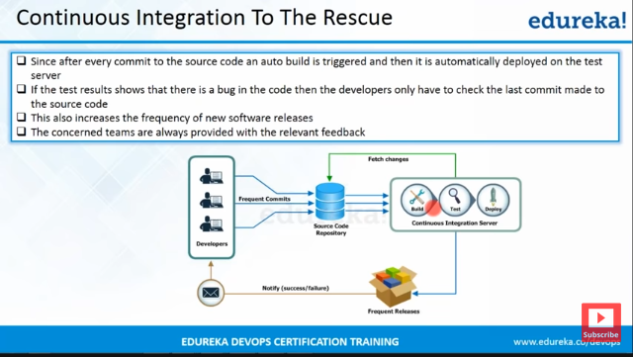

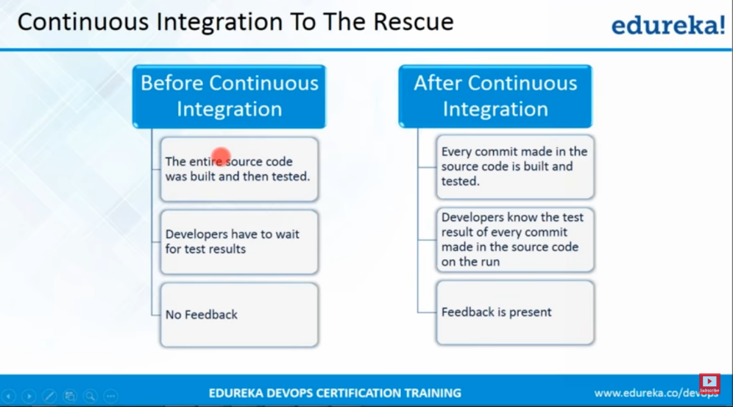

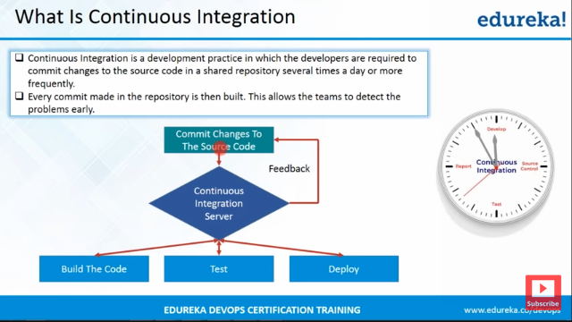

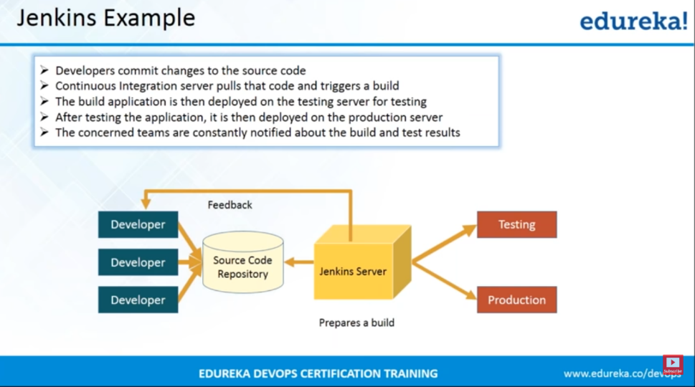

Jenkins Master-Slave Architecture:

Node Machine Configurations:

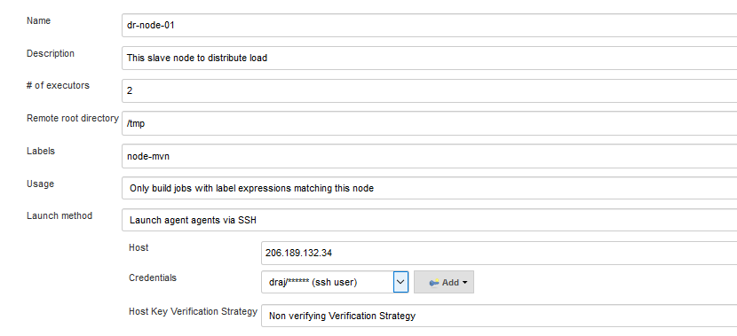

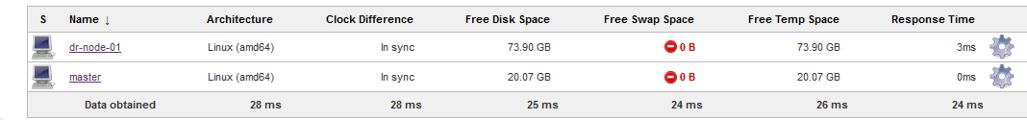

**When Jenkin master –node is on windows then way to connect to each other**

* Select “launch agent via java web start” from drop down section in launch method.
* Click on save
* Agent is not connected now.
* To connect, Download the file slave.jar as shown below and run the command in slave machine to join to master.

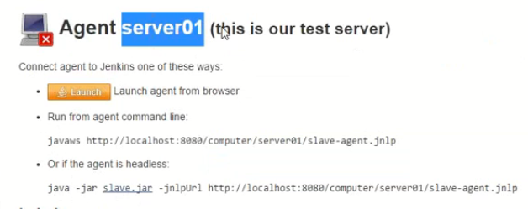

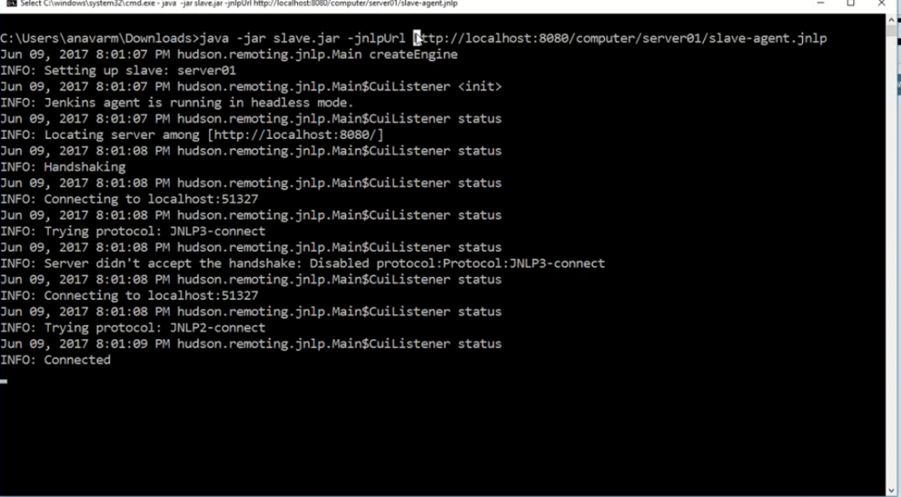

While configuring the job, you can restrict where to run the job. Below job is running on Node.

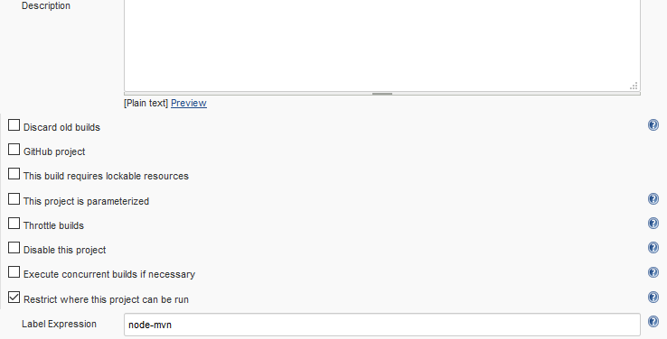

Jobs can be run on demand and schedule basis

**JenkisPipeLine using groovy Script**

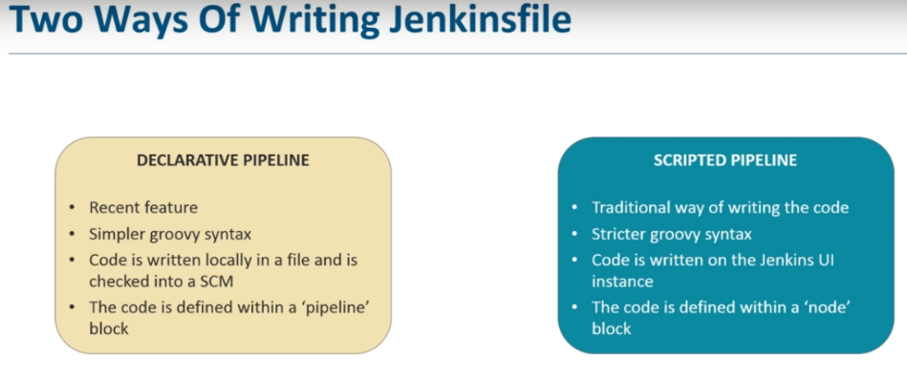

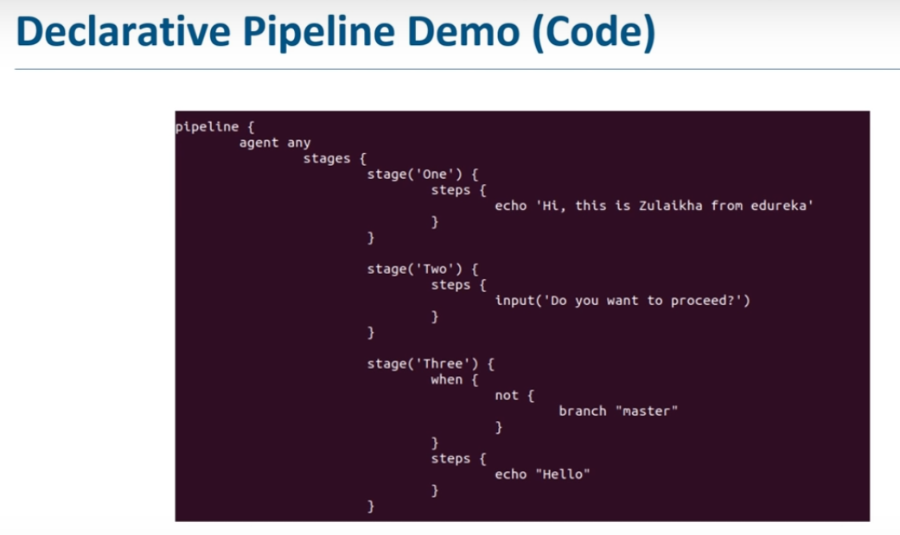

Agent “any” specifies that each steps will run on any agent unless new agent is defined in any of the stages

Jenkins pipeline videos:

<https://www.youtube.com/watch?v=_fmX31VFbL8>

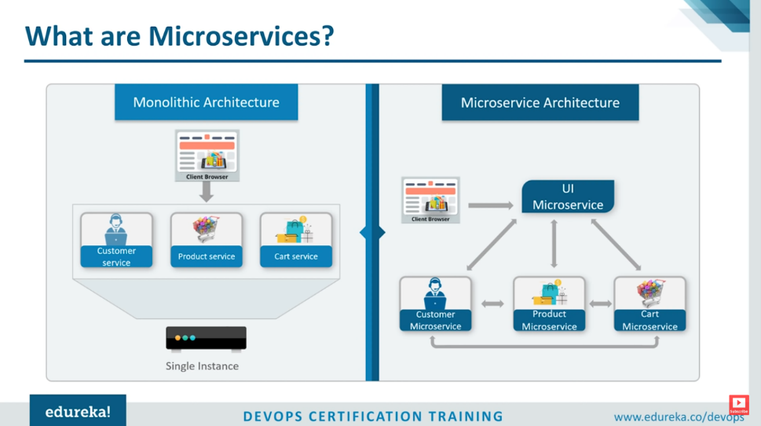

<https://www.youtube.com/watch?v=hMlr1KlazBk>

(Micro Services Deployment with Docker & Jenkins)

**MICRO SERVICES DEPLOYEMENT USING DOCKER CONTAINERS AND JENKINS**

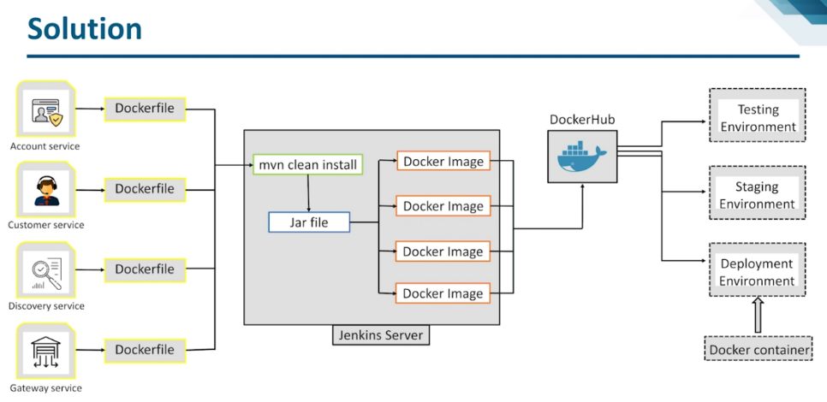

Build Scheduling Options:

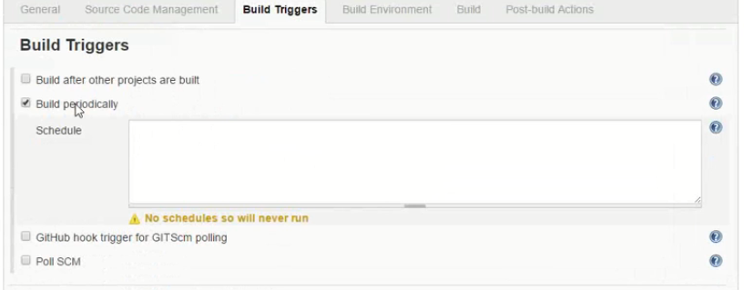

CRON Defined 🡪 Minute, hour, day of month, Month, Day of The Week

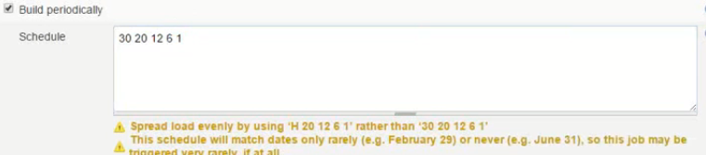

30🡪Minute

20🡪Hour

12🡪 Day of the month

6🡪Month

1🡪 Monday( day of week)

**Installing Jfrog on Linux**:

<https://www.youtube.com/watch?v=IFF-jnAxlDs>

<https://www.youtube.com/watch?v=fxtQThl8B-8>

**Install jfrog on Ubuntu**

<https://www.shashankk.in/2018/11/05/installing-artifactory/>

**Integrating Jfrog with Jenkins:**

* Install the below plugin



* Click on configure system and add jfrog server URL and login credentials

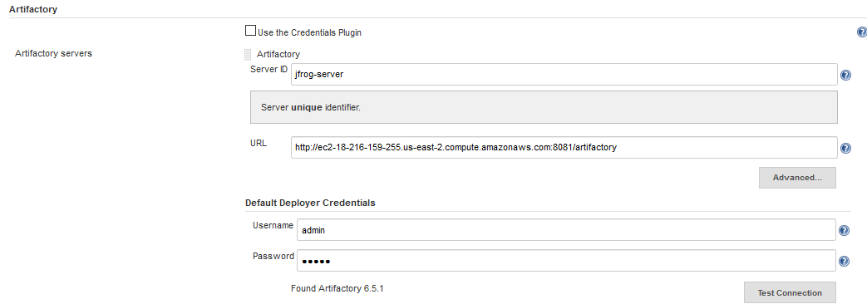

* Create a new job and enter git hub url.
* Configure below settings as shown

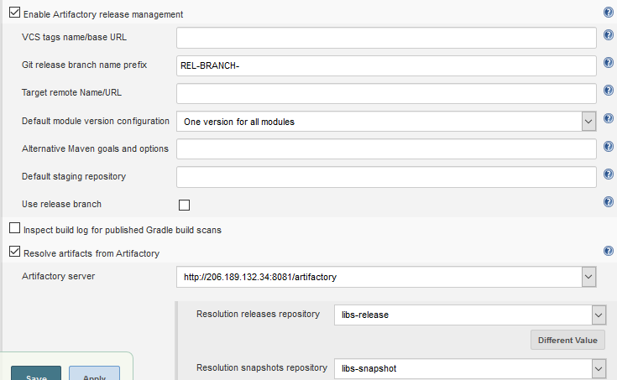

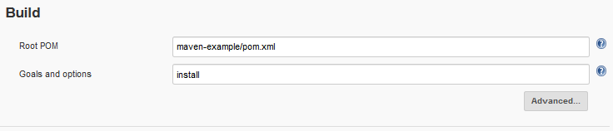

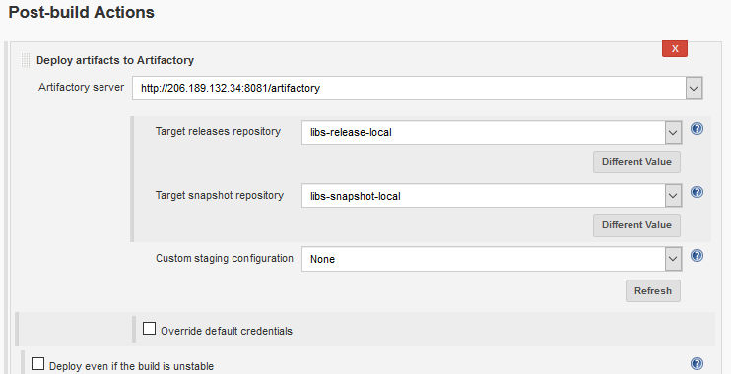

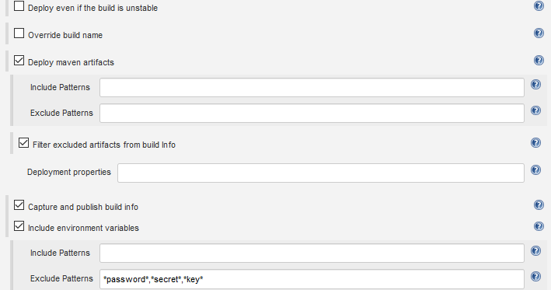

* Save and apply
* Run the build, build should be successful.
* Build is pushed to artifactory.

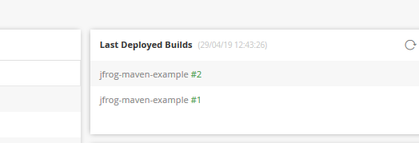

**Build Management (MAVEN)**

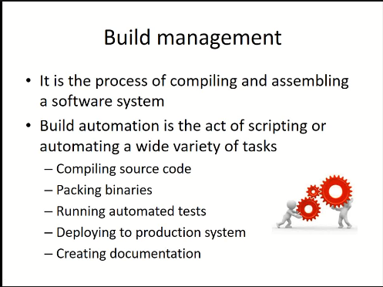

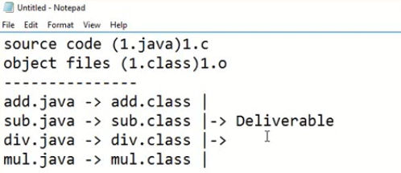

**Build Automation**🡪 Creating class files and preparing deliverables out of source code is all an automated process called as Build automation, also take care of automated tests.

Deploying to certain environments like test, production etc.

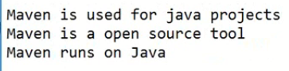

Maven is also a project management tool.

* When you perform any goals like compile, it will call the plugin associated to that goal and perform the task.

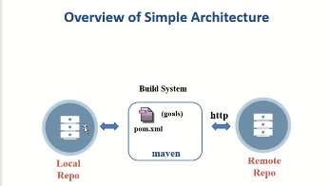

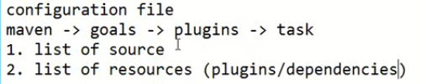

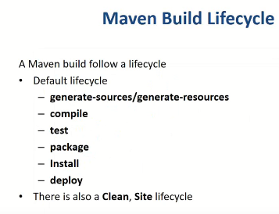

Generate sources and resources phase:

In the above diagram, when you run maven for the first time, below activities will be performed:

1. It will check the list of sources (source code) in the current working dir.
2. It will check the list of resources (plugins) in the local rep.
3. If the plugins are not in local then it will download from remote repo
4. If there is no internet then local repo will unable to connect to remote repo.

Compile phase: converting raw source to object file.

1. Java 🡪 compile 🡪 1.class

Test Phase:

For every java file there is corresponding test file to perform unit test.

Mvn test will create .class files for all the test related source code which will perform on Java files.

Test1.java🡪 compile🡪 Test1.class

Test1.java will perform on 1.Java

Test-classes folder will created under target directory after running mvn test. This test-classes folder will have .class files for test-case code.

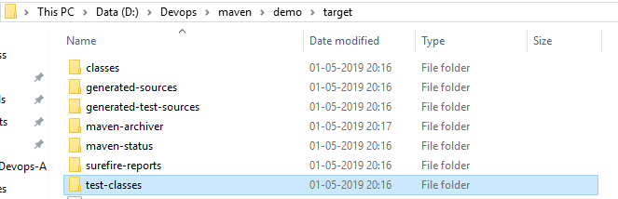

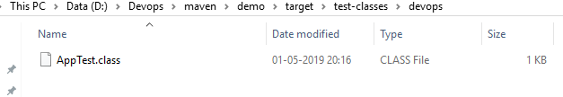

Packaging phase

Out of these class file, we have either jar or war or ear.

Jar🡪 combination of several jar files

War🡪 combination of several class file and html, xml files for web based app.

Maven Install phase:

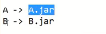

* Whenever you ran A.jar it will create a copy and store the output of that project/deliverable from working dir to local repo is called Install, so that any project which is dependent on that will be referred from local repo.
* So, when you run other project say B.jar which is dependent of A.jar the it will look for A.jar in local repo.

Deploy phase:

Whenever you want copy the deliverable (jar, war, ear) to a certain location from where the application is accessed is called as deploy phase.

1. Test environment
2. Staging environment
3. Production environment

**VERY IMPORTANT PONIT**

**Whenever you define maven goal, it will start from beginning of the phase and stop at the point you defined.**

**Example: *maven package*:**

**Then it will start from generate source/resource, then compile, test and stops at package.**

**When you say *maven compile*, Then it will start from generate source/resource and tops at compile phase.**

Clean:

* Clean will not start from beginning and will only run clean.
* It will delete all the run time files from the project folder. Like .class files ,jar/war, test results
* Delete entire target folder.

Site: Site is also a non-default lifecycle.

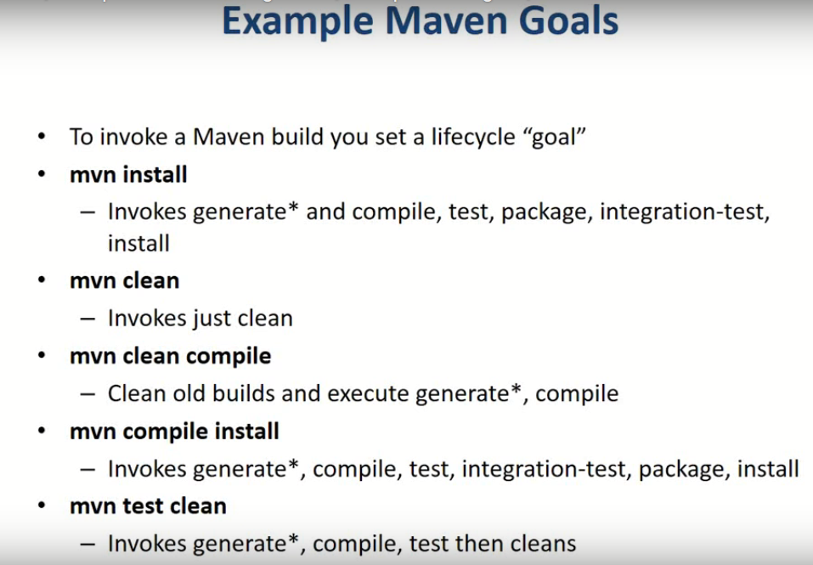

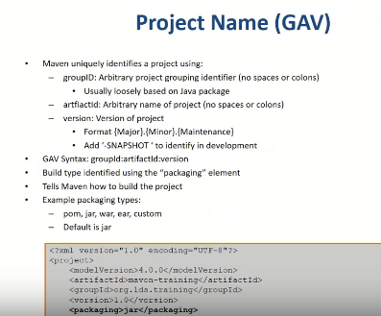

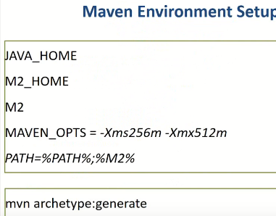

M2 🡪 refers to a value “bin directory” under maven home directory

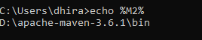

Set m2 repository in PATH variable

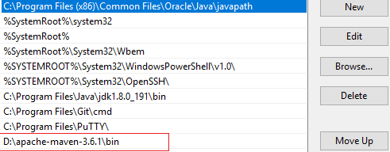

Maven Repositories

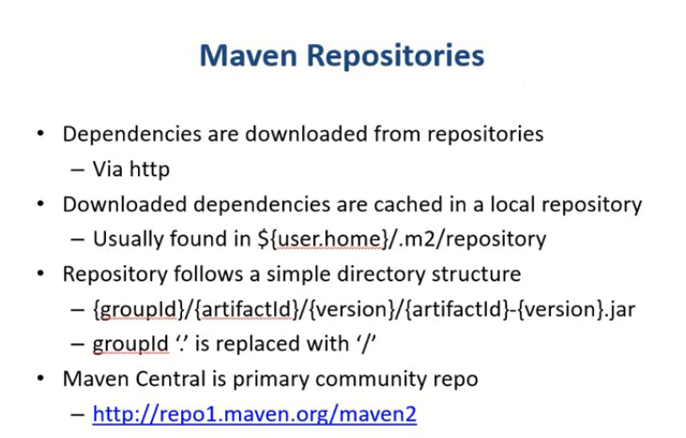

Local Repo Windows:

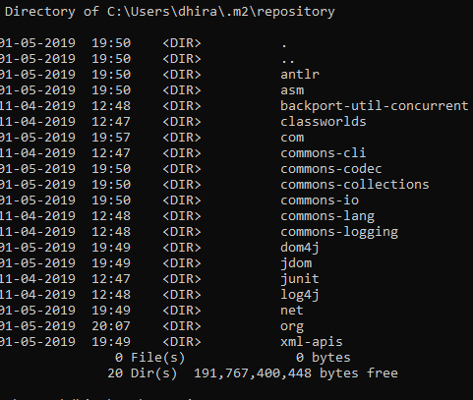

Ubuntu maven-repo location i.e. /usr/share/maven-repo

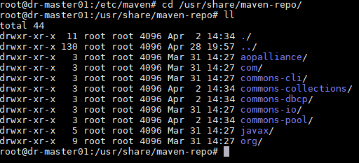

In settings.xml file we can change the default location of local repo.

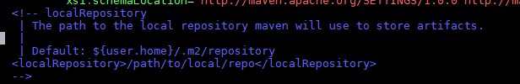

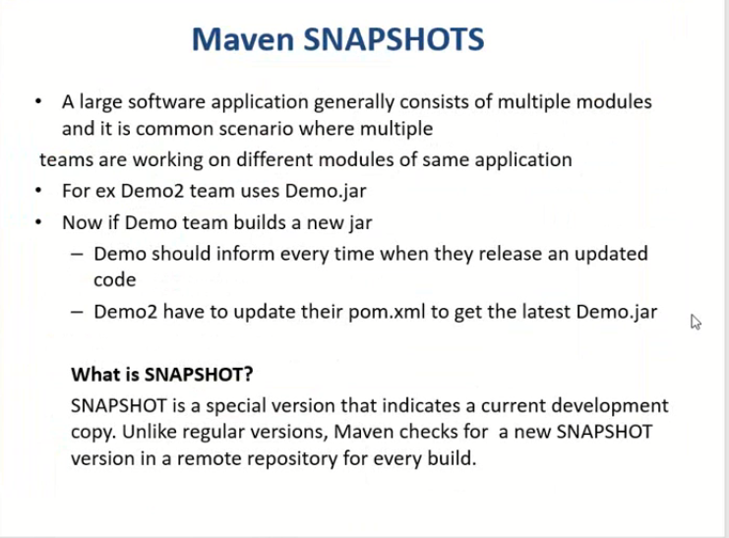

**Maven Snapshots:** It is a special version number which indicates that currently working on development cycle and will give the version number only after the release.

**KUBERNETES WALK-THROUGHS**

**Srinath Challa Videos for Kubernetes:**

[**https://www.youtube.com/watch?v=_3NUI5vasPk&list=PLMPZQTftRCS8Pp4wiiUruly5ODScvAwcQ&index=10**](https://www.youtube.com/watch?v=_3NUI5vasPk&list=PLMPZQTftRCS8Pp4wiiUruly5ODScvAwcQ&index=10) **🡪 Refer this**

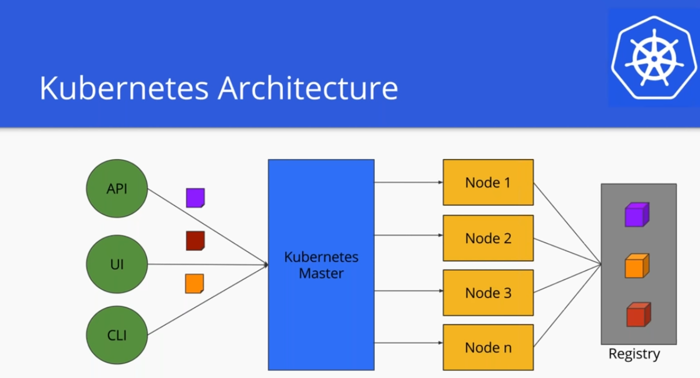

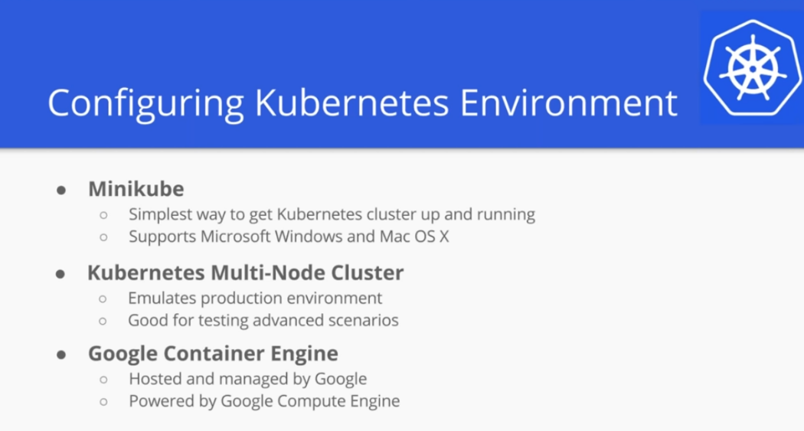

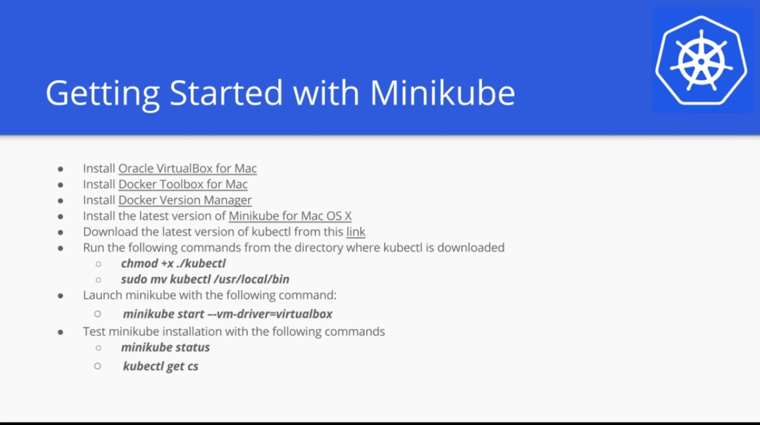

* Most powerful tool to deal with Kubernetes is **Kubectl** written in go language.

**KUBERNETES MASTER**

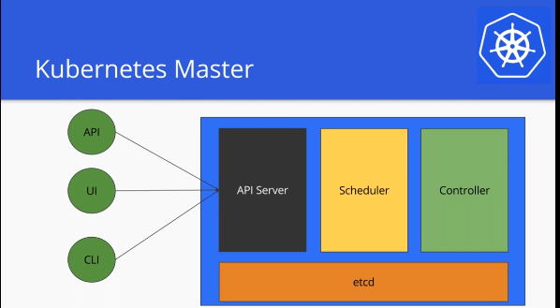

* Anything and everything has to pass through API-server first.
* Scheduler: Schedules the pods or containers across the nodes.
* Controller: Responsible for coordination and health of the cluster. It ensures that nodes are up and running.
* etcd: Key-value database. Light base Db. Stores state of cluster.

**KUBERNETES NODES:**

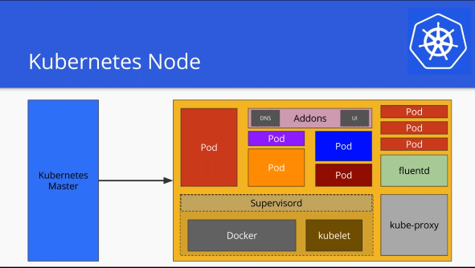

Kube-proxy

* Responsible to maintaining network configuration
* Manipulates IP tables on each nodes, each hosts to make sure network configuration is intact.
* One pod talk to another pod, one node talk to another node.
* It also exposes services.
* N/w is maintained across the cluster.

**Kubelet**

* An agent responsible for reporting the health/metrics of nodes to Master.
* Kubelet talks to API to reporting to master.
* Kubelet runs on every node.

**Supervsiord:**

* A process manager where you can run multiple process.
* Both Docker and kubelet are packaged in supervisord layer.
* It ensures Docker and Kubelet running all the time.

**Fluentd:**

* Responsible for managing the logs and talking to central logging mechanism if configured.

Every nodes can run different pods

Nodes are also have Add-ons like DNS, UI (optional)

**KUBERNETES PODS**

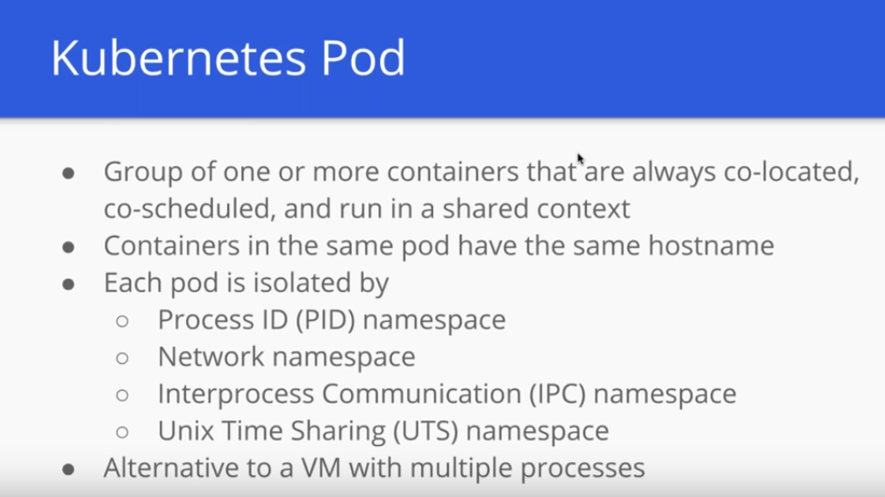

* In kubernetes, unit of deployment is PODS.

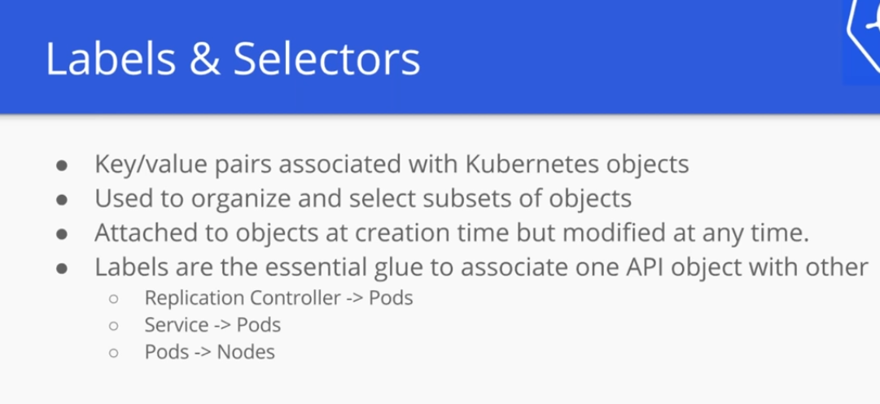

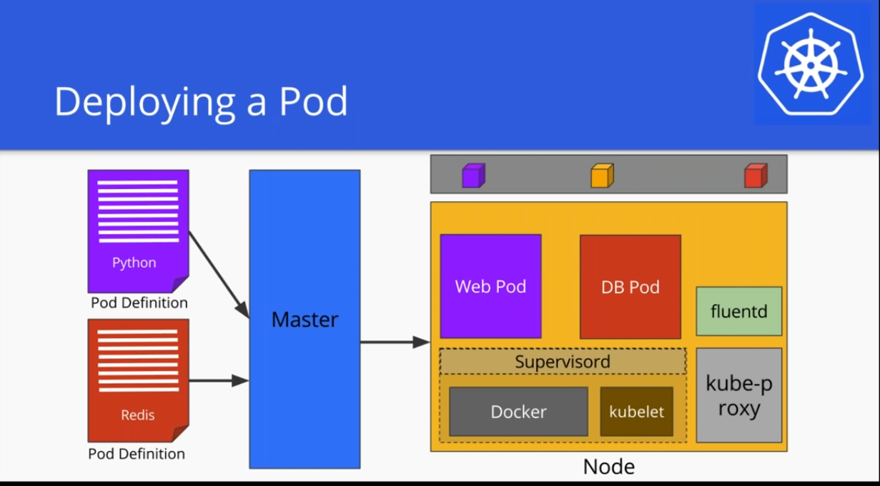

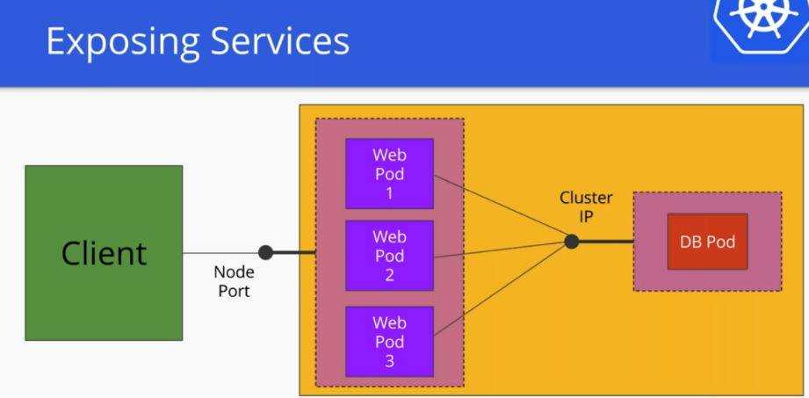

Monolithic Architecture

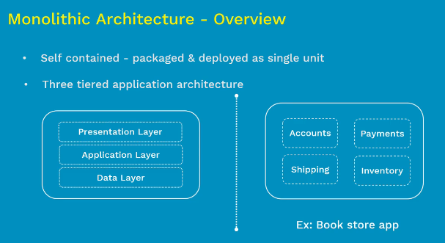

* Kubernetes manages the containerised app in large scale.
* Pods is a collection of one or more pods.

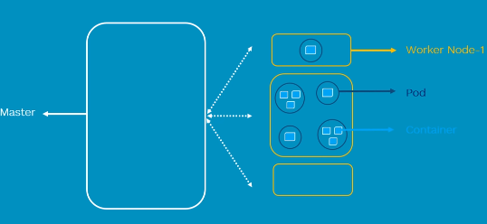

* Master monitors the health check of all worker nodes.
* If worker nodes fails then master moves the load to more healthy nodes.

**Complete Architecture of Kubernetes**

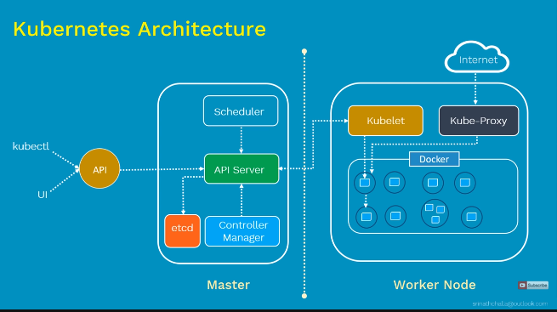

**Terminology**

